Naíscoil agus Gaelscoil
an tSeanchaí

Réamheolaire
2020-21

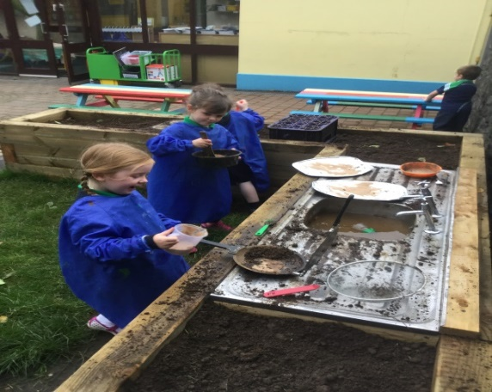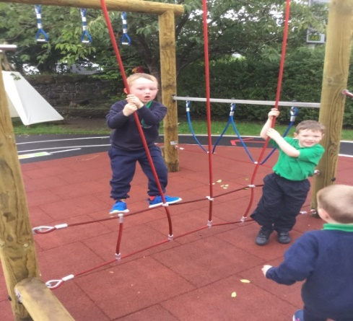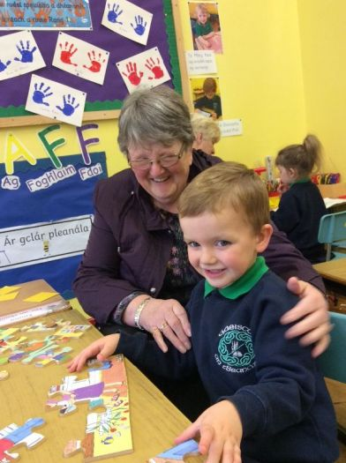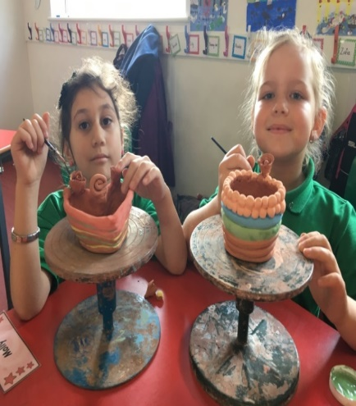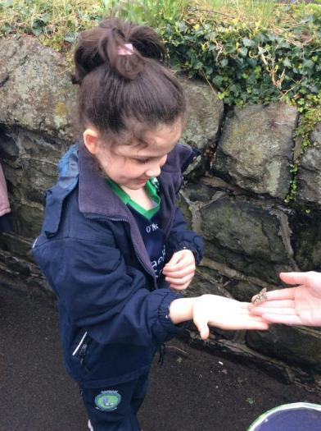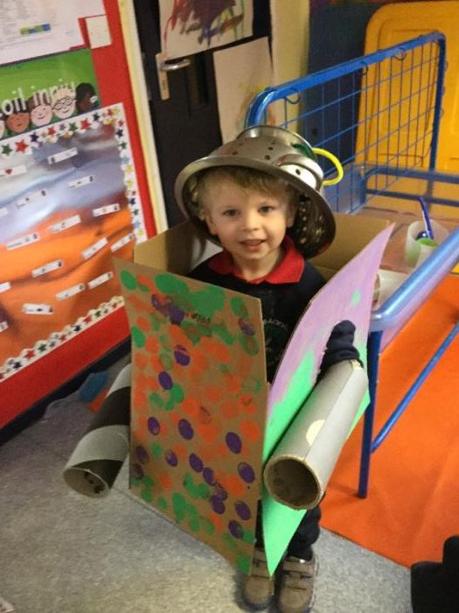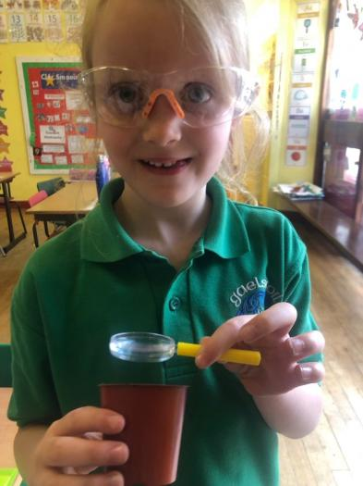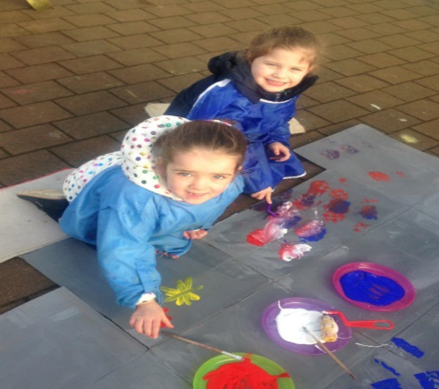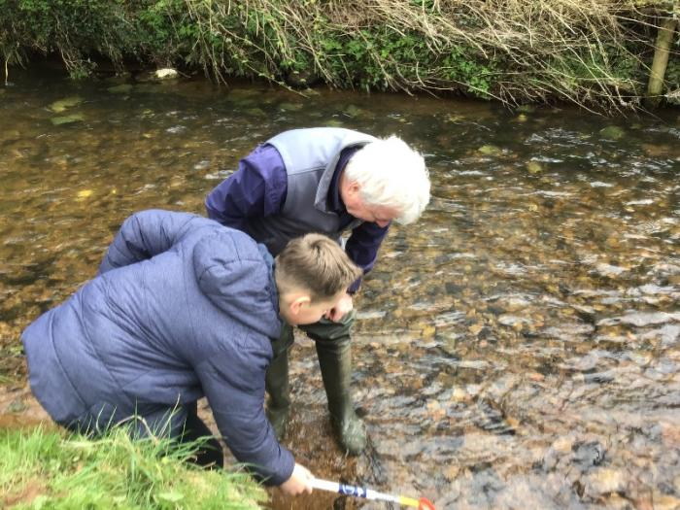
www.gaelscoilantseanchai.com
Clár

- Fáilte an Phríomhoide
- Eolas Teagmhála
- Laethanta Saoire Scoile
- Clárú agus UImhreacha Iontrála
- Socruithe Iontrála-Naí-Aonad
- Socruithe Iontrála - Gaelscoil
- Bord na nGobharnóirí
- Foireann Ghaelscoil an tSeanchaí
- Gnáthlá Naíscoile
- Curaclam Naíscoile
- Curaclam na Bunscoile
- Béarla
- Riachtanais Speisialta Oideachais
- TFC
- Obair Bhaile
- Gnáthlá Bunscoile
- Poncúlacht agus Tinreamh
- Béilte Scoile
- Polasaí Bhia Shláintiúil
- Éide Scoile
- Seodra
- Dátheangachas
- Gníomhaíochta Breischuraclaim
- Cosaint Páiste
- Treoirlíntí Sábháilteachta
- Cúram Tréadach
- Am Ciorcail
- Oideachas Drugaí
- Caidrimh agus Oideachas Gnéis
- Dea-iompar
- Smacht
- Creideamh
- Caidrimh Phoiblí
- Comhairle na nDaltaí
- Rannpháirteachas Tuistí
- Cuairteanna Scoile
- Ag Tuairisciú do Thuismitheoirí
- Scoileanna Roghnaithe ag Daltaí Rang 7
- Gearáin

Fáilte an Phríomhoide

A Thuismitheoir, a chara,

Ba mhaith liom, ar son gach duine i Naíscoil agus i nGaelscoil an tSeanchaí, fearadh na fáilte a chur romhaibh go Gaelscoil an tSeanchaí. Tá súil againn go mbeidh do pháiste sona anseo linne sna blianta tábhachtacha seo agus é/í ar an bhunscoil.
Tá an-lúcháir orainn gur roghnaigh tú an Ghaelscolaíocht agus go háirithe Gaelscoil an tSeanchaí.
Cuirimid an réamheolaire seo ar fáil le go dtig leat fáil amach faoin saol scoile. Bíonn tacaíocht ár gcuid tuismitheoirí an-tábhachtach ar fad agus is mar gheall ar an tácaíocht sin gur éirigh chomh maith le daltaí na scoile seo ó bunaíodh í. Cuirimid fáilte roimh cheisteanna, smaointí úra agus aischothú a bhaineann le saol na scoile. Tá béim nach beag ar an síorfheabhsú agus creidimid go mbeidh deis iontach ag do pháiste Gaeilge a fhoghlaim i dtimpeallacht atá sultmhar agus leasaithe. Tá cur síos ar na buntáistí a bhaineann leis an oideachas dátheangach níos faide anonn sa réamheolaire. Is é an aidhm atá romhainn ná páistí a bheas líofa agus muiníneach sa dá theanga a chruthú.

Tá mé ag dúil go mór le bheith ag comhoibriú libh.

Deirdre Nic Suibhne

Príomhoide

Eolas Teagmhála

Naíscoil agus Gaelscoil n tSeanchaí
SEOLADH: 40 Sráid an Tionóil
Machaire Fíolta
Co.Dhoire
BT45 6BW

GUTHÁN: 028 79300532 (Bunscoil)
028 79634663 (Naíscoil)

RÍOMHPHOST: info@gaelscoilantseanchai.ni.sch.uk

CATHAOIRLEACH
BHORD NA NGOBHARNÓIRÍ: Jacinta Duggan

PRÍOMHOIDE: Deirdre Nic Suibhne

STADÁS: Faoi Chothabháil

CINEÁL: Bunscoil Lán-Ghaelach

AOISRAON: 3 & 4 - Naíscoil
4 – 11 - Bunscoil

LÍON DALTAÍ: 26 Naí-Aonad
113 Scoil
% TINREAMH 2014- 2015: 94.5%
% TINREAMH 2015- 2016: 95.2%
% TINREAMH 2016- 2017: 96.8%
% TINREAMH 2017- 2018: 96.4%
Laethanta Saoire Scoile 2020 – 2021 ( le cinntiú)

Tosaíonn Rang 1 ar an 31 Lúnasa 2020, páistíí naíscoile ar an 3 Meán Fómhair agus gach dalta eile ar an 24 Lúnasa
Meán Fómhair | 25
Deireadh Fómhair | 26-30
Samhain | 27
Nollaig | 23-31
Eanáir | 1-6
Feabhra | 15-19
Márta | 17-18
Aibreán | 2-9
Bealtaine | 3-4  28-31
Meitheamh | 28-30

Clárú agus Uimhreacha Iontrála 2019 – 2020
D‛athbhreathnaigh Roinn an Oideachais an uimhir chláraithe agus an uimhir iontrála mar a leanas don scoilbhliain 2019 – 2020:

Uimhir Cláraithe, Meán Fómhair 2019 | 19 – Rang 1  26 – Naíscoil
Uimhir iontrála, Meán Fómhair 2019 | 19 - Rang 1  26– Naíscoil

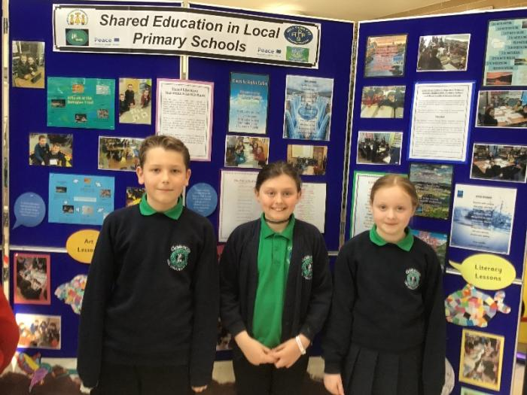

Is breá liom an scoil mar thig liom cuidiú le mo mhamaí Gaeilge a labhairt sa bhaile. Tá aithne agam ar achan duine sa scoil agus tá sin maith.

NAÍ-AONAD AN tSEANCHAÍ: Critéir agus Socruithe Iontrála 2020

Critéir Iontrála
Tá clár ama a leagann amach na dátaí a bhfuil iarratais le bheith istigh ar fáil ar www.eanni.org.uk/admissions faoi ‘Pre-school Admissions’. Le linn an phróiséas iontrála agus critéir a chur i bhfeidhm, cuirfear iarratais a thagann isteach in am san áireamh sula gcuirfear iarratais a thagann isteach mall san áireamh.
Osclófar an modh iarratais ar an 7 Eanáir 2020 ar 12 meánlae agus glacfar le hiarratas a thagann isteach roimh meánlae ar an dáta deiridh 30 Eanáir 2020 mar iarratas tráthúil. Glacfar le hiarratas a thagann isteach i ndiaidh12 meánlae ar 30 Eanáir 2020 mar iarratas mall.
Ar an ábhar go bhfuil dhá staid leis an chórás iontrála seo leagann an clár ama amach na dátaí ag Staid 2 a bhaineann le h-iarratas a bheith mall nó in am.
Is iad seo na critéir iontrála a chuirfear i bhfeidhm i dtaobh áiteanna. Tá na critéir leagtha síos in ord tosaíochta.

Glacfar le páistí de réir na gcritéar reachtúil seo a leanas:

1. Páistí ó chúinsí faoi mhíbhuntáiste sóisialta ina mbliain dheireanach réamhscolaíochta, i. páistí ar rugadh iad ón 2 Iúil 2016 go dtí an 1 Iúil 2017 (araon san áireamh);

2. Páistí nach luíonn faoi réimse fhopharagraif (1) ina mbliain dheireanach réamhscolaíochta;

agus dóibh siúd nach mbeidh áit réamhscolaíochta acu, lánaimseartha nó páirtaimseartha, ag scoil eile nó ag ar áitribh ar bith eile ag am beartaithe iontrála s’acu.

Nóta: Ciallaíonn "páiste atá faoi mhíbhuntáiste sóisialta," páiste a bhfuil tuiste aige/aici a fhaigheann (i) Liúntas Tacaíochta Ioncaim, nó (ii) Liúntas Cuardaitheora Post bunaithe ar Ioncaim nó (iii) nuair a chomhshóitear íocaíocht Liúntas Tacaíochta Ioncaim go Liúntas Fostaíochta agus Tacaíochta agus chinntigh An Ghníomhaireacht Slándáil Shóisialach go bhfanann an líon sochair mar a gcéanna nó (iv) Creidmheas Uilíoch. Nuair a chuireann tuiste isteach d'áit faoi chritéir thuas luaite, caithfidh gach tuiste cinntiú go bhfuil stampa an Ghníomhaireacht Slándáil Shóisialach ar an iarratais a dhearbhú go bhfuil siad i dteideal le ceann de na híocaíochtaí thuas luaite. Caithfidh an tuismitheoir seo a sheoladh chuig a sóláthróir chéad rogha.

I gcás go bhfuil an méid páistí atá ag iarraidh áiteanna níos mó ná an uimhir iontrála, bainfear úsáid as na fóchritéir thíos.

Fochritéir
- Páistí ar roghnaíodh Naí-Aonad an tSeanchaí mar chéad rogha dóibh.
- Páistí a bhfuil tuismitheoir/caomhnóir acu ar fhoireann Naí-aonad/Ghaelscoil an tSeanchaí.
- Páistí a bhfuil deartháir/deirfiúr nó leasdeartháir/leasdeirfiúr acu atá ag freastal ar Ghaelscoil an tSeanchaí cheana (léirigh ainm agus bliainghrúpa).
- Páistí a bhfuil an Ghaeilge mar phríomh theanga chumarsáide acu le tuismitheoir/caomhnóir sa bhaile.
- Páistí eile de réir ord na ndátaí breithe (an duine is sine ar tús).

Critéir nach dtiteann faoi reacht

Má bhíonn spásanna fágtha i ndiaidh don chritéir thualuaite a bheith curtha i bhfeidhm, tabharfar áiteanna do pháistí de réir ord na ndátaí breithe idir 2 Iúil 2017 agus 1 Iúil 2018 – an páiste is sine ar tús.

Critéir Iontrála Tar Éis 1 Meán Fómhair 2020
Sa chás go mbeidh spás/anna ar fáil i ndiaidh 1 Mheán an Fhómhair agus mó iarratasóirí ná spásanna ann, roghnófar daltaí trí na chéanna a chur i bhfeidhm ar na páistí siúd a bheas ag lorg iontrála ag an am a bheas an spás/na spásanna ar fáil.

Dualgas Fíoraithe
Coinníonn Bord na nGobharnóirí a cheart chun fianaise breise a iarraidh de réir mar a shocraíonn sé a bhfuil gá leis chun eolas a thacú nó a fhíorú ar Fhoirm Iarratais aon iarrthóra. Muna gcuirfear an fhianaise a hiarradh ar fáil do Bord na nGobharnóirí um an spriocdáta a tugadh, is é an toradh a bheas air ná tarraingt siar na háite a tairiscíodh. Ar an dóigh chéanna, má chuirfear eolas ar fáil a bhfuil an chuma air go bhfuil sé bréagach nó ar seachrán ar aon chaoi ar bith, tarraingeofar siar an tairiscint áite.

Liosta Feithimh
Má bhíonn folúntas ann I ndiaidh don Nós Imeachta Iontrála Oscailte teacht chun críche ar 8 Meitheamh 2020 is é beartas na scoile ná critéir chéanna a chur i bheidhm ar aon iarratais bhreise agus á gcur ar an liosta feithimh go dtí 30 Meitheamh 2021.

GAELSCOIL AN tSEANCHAÍ: Critéir agus Socruithe Iontrála 2020

CRITÉIR IONTRÁLA
Mar chuid den phróiséas iontrála agus critéir á chur i bhfeidhm, cuirfear iarratais a thagann isteach in am san áireamh sula gcuirfear iarratais nach dtagann in am san áireamh. Osclófar an modh iarratais ar an 7 Eanáir 2020 ar 12 meánlae agus glacfar le hiarratais a thagann isteach roimh meánlae ar an dáta deiridh 30 Eanáir 2020 mar iarratas tráthúil. Glacfar le hiarratas a thagann isteach i ndiaidh 12 meánlae ar 30 Eanáir 2020 mar iarratas mall.

- Páistí in aois éigeantach scoile a bhfuil deartháir/deirfiúr nó leasdeartháir/leasdeirfiúr acu atá ag freastal ar Ghaelscoil an tSeanchaí cheana.
- Páistí in aois éigeantach scoile a bhfuil deartháir/deirfiúr nó leasdheartháir/leasdheirfiúr acu atá ina iardhalta ar thumoideachas bhunscoile.
- Páistí in aois éigeantach scoile a d’fhreastal ar Naí-aonad an tSeanchaí nó Naíscoil na Fíobha.
- Páistí in aois éigeantach scoile a bhfuil tuismitheoir/caomhnóir acu ar fhoireann Ghaelscoil an tSeanchaí nó Naíscoil na Fíobha..
- Páistí in aois éigeantach scoile ar roghnaíodh Gaelscoil an tSeanchaí dóibh mar chéad rogha.
- Páistí in aois éigeantach scoile a bhfuil an Ghaeilge mar phríomh theanga chumarsáide acu le tuismitheoir/caomhnóir.
- Páistí in aois éigeantach scoile a bhfuil an seoladh baile is cóngaraí do gheataí na scoile acu.
- Páistí eile in aois éigeantach scoile de réir ord na ndátaí breithe (an duine is sine ar tús).
Sa chás go mbeidh an líon páiste a bheidh ag iarraidh áiteanna faoi cheann ar bith de na critéir thuasluaite níos mó ná an méid áiteanna a bheidh ar fáil déanfar roghnú de réir:
chéad litir an tsloinne (de réir chlárú an Teastais Breithe) ar bhonn an oird randamach atá leagtha amach thíos:

B Ní W Z N J T D L I H U M Mac G S Nic Ó A V C X de O P Q R Nig Mc E Y K F

Sa chás go dtosóidh sloinnte leis an litir chéanna úsáidfear litreacha eile an tsloinne in ord a dtarlaithe agus de réir oird aibítre. Sa chás go mbeidh comhshloinnte i gceist úsáidfear litreacha sa líon céanna chéad ainmneacha (de réir chlárú an Teastais Breithe) in ord a dtarlaithe agus de réir oird aibítre. Sa chás go mbeidh na litreacha céanna sna chéad ainmneacha a úsáidfear déanfar roghnú randamach a chlárófar.

IONTRÁLACHA BHLIAIN 1 - TAR ÉIS 1 MEÁN FÓMHAIR 2020

Glacfar le hiarratais iontrála sa chás go bhfaighfear in oifig na scoile iad roimh thús shaoire Oíche Shamhna. Sa chás go mbeidh spás ar fáil agus go mbeidh níos mó iarrthóirí ná spásanna roghnófar daltaí trí na Critéir Iontrála do Bhliain 1 a chur i bhfeidhm ar na daltaí siúd a bheas ag lorg iontrála ag an am a bheas an spás / na spásanna ar fáil.

DUALGAS FÍORAITHE

Coinníonn Bord na nGobharnóirí a cheart chun fianaise breise a iarraidh de réir mar a shocraíonn sé a bhfuil gá leis chun eolas a thacú nó a fhíorú ar Fhoirm Iarratais aon iarrthóra.

Muna gcuirfear an fhianaise a hiarradh ar fáil do Bord na nGobharnóirí / An Coiste Bainisteoireachta um an spriocdáta a tugadh, is é an toradh a bheas air ná tarraingt siar na háite a tairiscíodh. Ar an dóigh chéanna, má chuirfear eolas ar fáil a bhfuil an chuma air go bhfuil sé bréagach nó ar seachrán ar aon chaoi ar bith, tarraingeofar siar an tairiscint áite.

I ndiaidh don Nós Imeachta Iontrála Oscailte teacht chun críche ar 28 Aibreán 2020 is é beartas na scoile na critéir chéanna a chur i bhfeidhm ar aon iarratais bhreise agus á gcur ar an liosta fanachta.

LIOSTA FEITHIMH

I ndiaidh don Nós Imeachta Iontrála Oscailte teacht chun críche ar 7 féadfaidh 2020 is é beartas na scoile na critéir chéanna a chur I bhfeidhm ar aon iarratais bhreise agus á gcur ar an liosta feithimh.

CRITÉIR IONTRÁLA: BLIANTA 2-7

Táthar ag súil go mbeidh a sháith Gaeilge cheana ag páiste ar bith a ligfear isteach i mBlianta 2 go 7 gur féidir á theagasc sa bhliainghrúpa chuí. Glacfar leis go mbeidh sin amhlaidh nuair a chruthóidh tuismitheoir an pháiste gur fhreastail a pháiste ar oideachas Ián-Ghaeilge dá bhunscolaíocht iomlán.

Déanfar machnamh ar iontráil daltaí sa chás:

- nach rachaidh an scoil thar a Uimhir Chláraithe; agus
- dar le Bord na nGobharnóirí páistí nach ndéanfadh a n-iontrálacha dochar d'úsáid éifeachtach acmhainní na scoile.

Sa chás go bhfuil níos mó iarrthóirí inghlactha ná áiteanna atá ar fáil nuair atá an t-iarratas á mheá cuirfear na Critéir Iontrála do Bhliain 1 do pháistí atá in aois éigeantach scoile i bhfeidhm.

Iarratais agus Iontrálacha do Rang 1
Bliain | Líon Iarratas | Líon Iontrálacha
2017/2018 | 21 | 20
2018/2019 | 17 | 17
2019/2020 | 20 | 20
chuirfear eolas ar fáil a bhfuil an chuma air go bhfuil sé bréagach nó ar seachrán ar aon chaoi ar bith, tarraingeofar siar an tairiscint áite.
I ndiaidh don Nós Imeachta Iontrála Oscailte teacht chun críche ar 26 Aibreán 2018 is é beartas na scoile na critéir chéanna a chur i bhfeidhm ar aon iarratais bhreise agus á gcur ar an liosta fanachta.
LIOSTA FEITHIMH
I ndiaidh don Nós Imeachta Iontrála Oscailte teacht chun críche ar 9 féadfaidh 2019 is é beartas na scoile na critéir chéanna a chur I bhfeidhm ar aon iarratais bhreise agus á gcur ar an liosta feithimh.
CRITÉIR IONTRÁLA: BLIANTA 2-7
Táthar ag súil go mbeidh a sháith Gaeilge cheana ag páiste ar bith a ligfear isteach i mBlianta 2 go 7 gur féidir á theagasc sa bhliainghrúpa chuí. Glacfar leis go mbeidh sin amhlaidh nuair a chruthóidh tuismitheoir an pháiste gur fhreastail a pháiste ar oideachas Ián-Ghaeilge dá bhunscolaíocht iomlán.
Déanfar machnamh ar iontráil daltaí sa chás:
i. nach rachaidh an scoil thar a Uimhir Chláraithe; agus
ii. dar le Bord na nGobharnóirí páistí nach ndéanfadh a n-iontrálacha dochar d'úsáid éifeachtach acmhainní na scoile.

Sa chás go bhfuil níos mó iarrthóirí inghlactha ná áiteanna atá ar fáil nuair atá an t-iarratas á mheá cuirfear na Critéir Iontrála do Bhliain 1 do pháistí atá in aois éigeantach scoile i bhfeidhm. Iarratais agus Iontrálacha do Rang 1
Bliain | Líon Iarratas | Líon Iontrálacha
2016/2017 | 16 | 15
2017/2018 | 21 | 20
2018/2019  2019/20 | 17  20 | 17  19
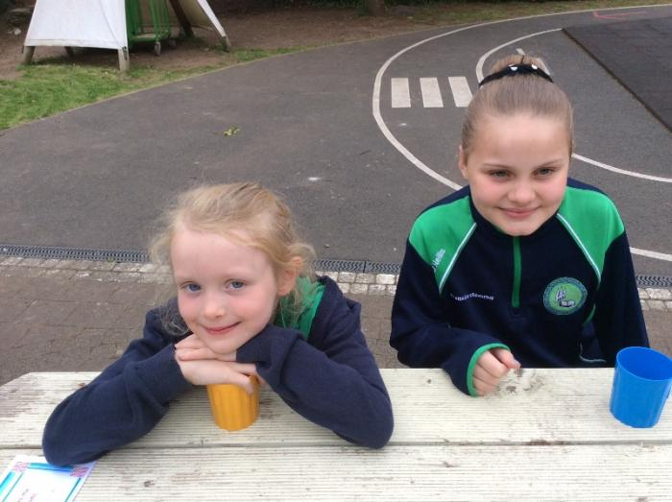

Gobharnóirí Scoile

Cathaoirleach  ÚO | Jacinta Duggan
Leas-Chathaoirleach  Ionadaí na gcaomhnóirí | Majella Bateson
Rúnaí | Deirdre Nic Suibhne  (gan vóta)
Ionadaí na Múinteoirí | Le líonadh
Ionadaí na dTuismitheoirí | Eimear O’Kane
DENI | Deirdre Ní Chinnéide
Ionadaí na gcaomhnóirí | Mark Gribben
ÚO | Déaglán Ó Doibhlín
Ionadaí na gcaomhnóirí | Louise Mc Quillan
Ionadaí na gcaomhnóirí | Le líonadh

Caomhnóirí na Scoile

Majella Bateson
Graeme Clarke
Damien Mc Conomy

Foireann Ghaelscoil an tSeanchaí

Príomhoide | Deirdre Nic Suibhne
Rúnaí | Rosaleen Mc Williams

Foundation Stage / Bonnchéim
Naí-Aonad | Bríd Uí Choinn | - Stiúrthóir naíscoile  - Oifigeach Chosaint an Pháiste sa Naíscoil

Rang 1 | Daniel Ó Donnaile
Rang 2/3 | Caitríona Nic an tSaoir | - Oifigeach Chosaint an Pháiste  - Bonnchéim/EC1
Key Stage 1 / Eochairchéim 1
Key Stage 2 /Eocharchéim 2
Rang 3/4 | Eibhlín Nic an tSaoir
Rang 5/6 | Síle Nic Giolla Domhnaigh | - DTO  - Accelerated Reader
Rang 7 | Eiméid Ó Raifeartaigh | Oifigeach chúnta do Chosaint an Pháiste

Teresa
Lorraine Cox
Clár Ní Chnáimhsí
Joanne Smith
Clár Ní Dhornáin
Naomi Doyle

Foireann Chúnta
Glantóir | Bernie Davey  Mary Henry
Maoir Lóin | Bernie Davey  Lorraine Cox  Claire Ní Chnáimhsí  Danielle Murphy  Naomi Doyle

Is breá liom an scoil seo mar bíonn muid ag dul ar léir turais scoile agus déanaimid léir spóirt. Dáire Rang 7

Gnáthlá Scoile – Naíscoile

Bíonn amanna Naíscoile ann idir 9.00am – 12.30pm. Tá am céimnithe ann agus is féidir le páistí teacht ar naíscoil am ar bith idir 8:45-9.15am. Tugann sin deis do thuismitheoirí labhairt leis an fhoireann más gá.

Bíonn sos sláintiúil ar fáil do pháistí go dtí 10.20am.
Gearrtar £20 in aghaidh na míosa ar thuismitheoirí le costas smailce a chlúdach.

Curaclam na Naíscoile
Clúdaíonn na daltaí sa Naíscoil Curaclam Thuaisceart Éireann (Bonnchéim).

• Forbairt Teanga
Caint agus éisteacht, léamh, scríobh, rím, siollaí, feasacht fóineolaíochta

• Forbairt phearsanta, shóisialta agus mhothúchánach
Am ciorcail, mothúcháin a fhiosrú, aire a thabhairt don timpeallacht, neamhspleáchas agus scileanna sóisialta.

• Luathéispéiris Mhataiticiúla
Dathana, cruthanna, uimhreacha, meaitseáil, sortáil, patrúin, míreanna mearaí

• Timpeallacht fhisiceach agus gluaiseacht
Siúl, rith, snámh ar urlár, léim, truslóg a thabhairt, dreapadh, scileanna liathróide, caitheamh

• Forbairt scileanna mórluaile agus mínluaile
Gearradh, snáithe a chur, scríobh, greamú, sceanra a úsáid

• Na hEalaíona
Dramhealaín, ceol, cnaguirlísí, sugradh samhlaíoch, dráma, rólghníomhaíocht

• An Domhan Thart Orainn
Ag tabhairt aire don timpeallacht, ag cur agus ag fás, sábháilteacht

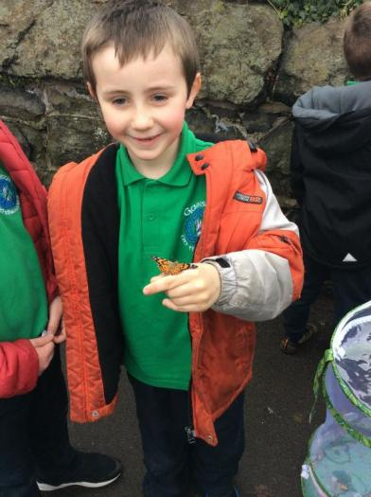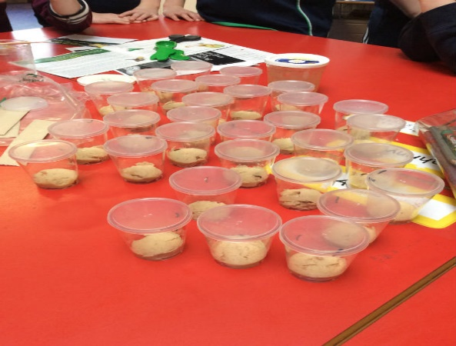
Curaclam na Bunscoile

Tá Curaclam na Bunscoile rannta ina dtrí eochairchéim:

Bonnchéim (Naíscoil, Rang 1 &2)
Eochairchéim 1 (Rang 3 & 4)
Eochairchéim 2 (Rang 5, 6 & 7)

Teagasctar do dhaltaí na scoile ábhair Churaclam Thuaisceart Éireann, díreach mar a gcéanna lena bpiaraí inár scoileanna Béarla máguaird. Áirítear raon limistéir foghlama sna hábhair:

• Teanga agus Litearthacht
- Léamh, scríobh, labhairt agus éisteacht.
• Matamaitic agus Uimhreas
- Uimhreas, cruth agus spas, láimhseáil sonraí, sórtáil, patrúin, tomhais, próisis.
• An Domhan Thart Orainn.
- Tíreolaíocht, stair, eolaíocht agus teicneolaíocht
•Forbairt Phearsanta
- Sláinte agus sábháilteacht phearsanta, comhthuiscint.
• Na hEalaíona
- Ealaín, ceol, dráma
• Oideachas Fisiceach
• Reiligiún

Aithnímid go mbíonn páistí ag foghlaim ar dhóigheanna difriúla, mar sin de agus muid ag pleanáil, cuirimid san áireamh na cineálacha difriúla intleachta a dhéanann cinnte go bhfuil gné radhairc, éisteachta, chinéistéiseach bainte le gach ceacht.

Béarla
Bíonn oideachais na bpáistí tugtha trí mhéan na Gaeilge amháin sna luathbhlianta le ligint do na páistí an Ghaeilge a thógáil ar dhóigh nádúrtha agus struchtúrtha. Bíonn Béarla acu mar ábhar foirmiúil ó thús Rang 4 agus bíonn na ceachtana seo déanta trí mhéan an Bhéarla chomh maith. Tá sé mar chuspóir againn an leibhéal céanna sa Bhéarla a bhaint amach ag deireadh Rang 7 agus atá sa scoileanna Béarla.

Riachtanais Speisialta Oideachais

I nGaelscoil an tSeanchaí, leanaimid na teoirlínte ó Roinn an Oideachais maidir le bainistiú agus le soláthar i dtaca le riachtanais speisialta oideachais. Aimsíonn múinteoirí straitéisí cuí agus cuireann siad iad i bhfeidhm le cuidiú le gach páiste ina rang agus oibríonn siad leis an CRSO (Comhordaitheoir Riachtanais Speisialta Oideachais) chun pleananna oideachasúla a dhearadh do gach dalta atá cláraithe ar Clár Riachtanais Speisialta Oideachais na Scoile. Leanann Gaelscoil an tSeanchaí cur chuige cúig chéim maidir le bainistiú agus soláthar Riachtanais Speisialta Oideachais mar atá leagtha amach sa Chód Cleachtais (DENI, 1998). Déantar athbhreithniú agus monatóireacht ar gach cás ar bhonn aonair agus ar bhonn rannpháirteach lena chinntiú go bhfuil múinteoirí, tuismitheoirí, CRSO, gníomhaireachtaí seachtaracha agus ar ndóigh na páistí iad féin ar an eolas agus forghníomhach a mhéad is féidir. Tá cóip de Pholasaí Riachtanais Speisialta Oideachais ar fáil ach é a iarraidh.

TFC

Is é is aidhm le Gaelscoil an tSeanchaí faill a thabhairt do pháistí dul i dtaithí ar gach gné de TFC agus a thábhachtaí agus a fhóirsteanaí atá sé don saol mór a chur ar a súile. Cuirtear in iúl do pháistí faoi na dóigheanna is féidir le heolas ríomhaire a úsáid le leas an pháiste. Forbróidh siad feasacht ar an dóigh ar féidir le TFC a mhí-úsáid in amanna agus ar bhealaí is féidir leo féin agus le faisnéis a chosaint. Tá Polasaí TFC agus Polasaí Rochtana Idirlín ar fáil ach iad a iarraidh.

Obair Bhaile
Is gné iontach tábhachtach de obair na scoile an Obair Bhaile agus is pointe rialta teagmhála í leis an scoil do mhórán tuismitheoirí. Tabhafar obair bhaile do gach páiste ag teacht leis an chumas s’acu le gur féidir:
a) obair ranga a dhaingniú
b) cuidiú leis an dalta nós staidéir a chothú
c) tuismitheoirí a choinneáil ar an eolas faoi obair a gcuid páistí
d) deis a thabhairt do thuismitheoirí bheith páirteach in obair a gcuid páistí. Ba chóir do thuismitheoirí léamh lena bpáistí agus obair bhaile scríofa ar bith a shíniú gach oíche.
Gnáthlá Scoile - Bunscoil

_________________________________________________________________________

Uaireanta Ranga

Rang 1 & 2 9.00am – 2.00pm
Rang 3 9.00am – 2.00pm (go dtí Oíche Shamhna)
9.00am – 3.00pm (i ndiaidh Oíche Shamhna)
Rang 4 – 7 9.00am – 3.00pm

Bíonn sos stiúrtha ag na páistí le linn sheisiún na maidine. Bíonn deis ann dul chuig an leithreas agus faoiseamh ón obair ranga sa chlós nó sa seomra ranga a fháil.
__________________________________________________________________________

Am Lóin

Rang 1 -3/4 12.00pm – 12.45pm
Rang 4 – 7 12.45pm – 1.30pm

Bíonn béilte scoile ar fáil i mbialann Ghaelscoil, ant Seanchaí. Tagann na béilte ó Bhunscoil Mhachaire Fíolta agus cosnaíonn siad £2.60. Itear lóin pácáilte sna ranganna. Bíonn cúntóir lóin ag tabhairt aire do na páistí sa bhialann agus sna ranganna ag am lóin, agus taobh amuigh agus iad ag súgradh.
__________________________________________________________________________

Club 2 – 3

Cuireann muid an tseirbhís seo ar fáil do thuismitheoirí a thógann páistí ar 3.00pm nó atá ag iarraidh tuilleadh ócaidí sóisialta da bpáiste. Bíonn gníomhaíochtaí éagsúla le linn na seachtaine – ealaín, ceol, damhsa, spórt. Tá costas £2.00 in aghaidh an lae air seo atá le híoc ag tús na míosa nó tús gach téarma.

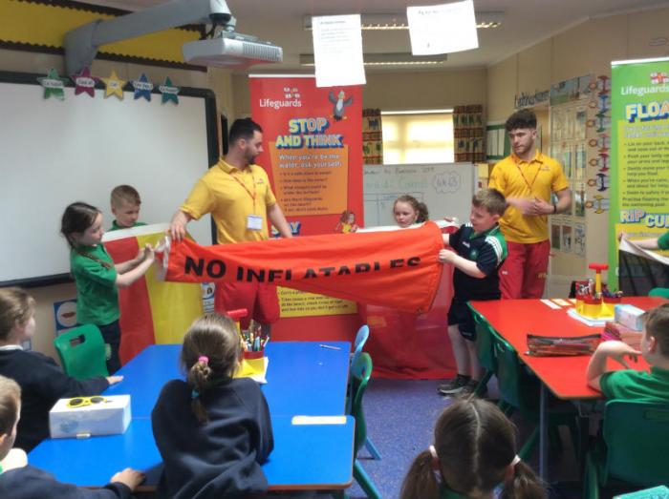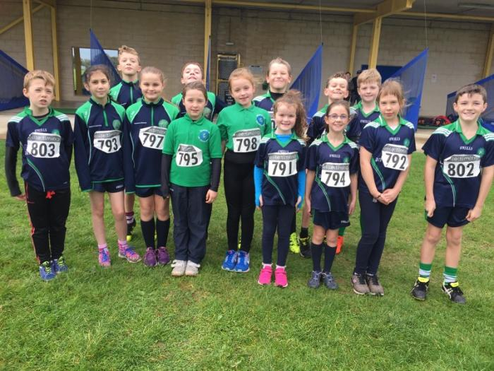
Poncúlacht & Tinreamh

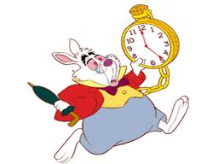
Bíonn luach oideachasúil le gach ceacht i nGaelscoil an tSeanchaí agus mar sin tacaíonn tinreamh agus poncúlacht le foraidhm na scoile mar atá foghlaim an dalta. Baineann neamhláithreachtaí fada, tinreamh mírialta agus easpa poncúlachta an bonn de ghnóthachtáil oideachasúil agus bíonn míbhuntaiste fadtéarmach in ann do pháistí mar gheall air.
Má thagann daltaí go mall ní mór dóibh tuairisciú d’Oifig na Scoile. Beidh páistí cláraithe mar ‘Mall’ i ndiaidh 9.00am. Cláróidh an rúnaí iad sa Leabhar Poncúlachta agus, más gá, clárófar go bhfuil béile de dhíth. Má tá páiste cláraithe sa leabhar ar mó é na ceithre huaire in aon mhí amháin cuirfear litir chuig tuismitheoirí ag cur in iúl a leithéid. Má éisítear litir níos mó ná dhá uair in aon téarma acadúil cuirfear fios ar an Oifigeach Leasa Oideachais. Má thagann dalta i ndiaidh don chlárú a dhruidim ar 9.30am beidh siad cláraithe mar as láthair don lá.

Béilte Scoile

Má shíleann tú go bhfuil do pháiste i dteideal béilte saora, is féidir foirm a fháil ó www.eani.org.uk. Tá sé rí-thábhachtach go líontar an fhoirm isteach agus go gcuirtear ar ais chuig an seoladh ar an chúl chomh gasta agus is féidir.

Polasaí Bhia Shláintiúil

Cuireann muid an-bhéim ar bhia sláintiúil agus iarrtar ar thuismitheoirí gan bia a thabhairt dá gcuid páistí le cuid mhór siúcra nó saille. Ní cheadaíonn an scoil ach torthaí amháin don sos maidine. Iarrtar ar thuismitheoirí gan seacláid, milseáin agus brioscán phrátaí a thabhairt dá gcuid páistí don lón. Tá cead ag páistí ‘treat’ beag a ghlacadh i mbosca lóin gach Aoine – Aoine Aoibhinn.
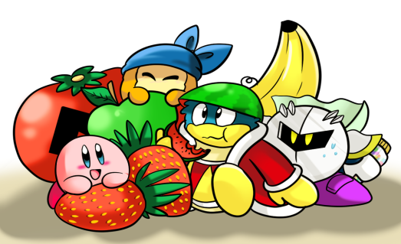

Éide Scoile
Tá sé riachtanach go gcaitheann gach dalta culaith scoile iomlán. Is féidir culaith na naíscoile agus na bunscoile a cheannach ó Select, Machaire Fíolta.
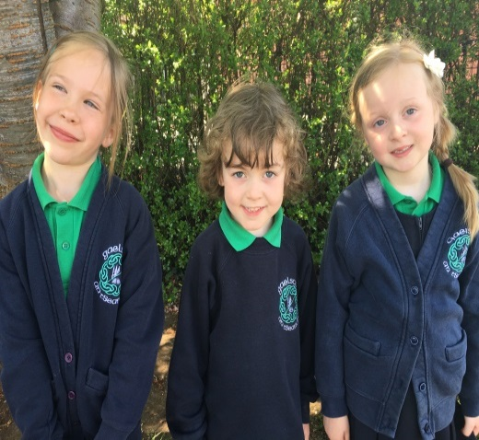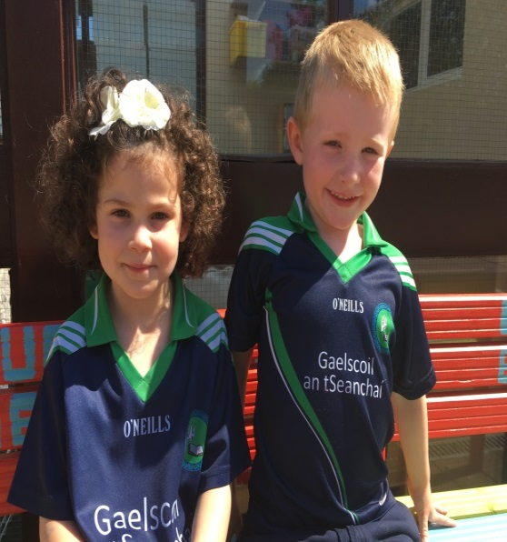
 | Cailíní | Gasúir
Naíscoil | Geansaí scoile  T-léine ghlas  Brístí dubhghorm  Brógaí le Velcro
Rang 1 – 7 | Sciorta nó bristí atá dubhghorm  Geansaí scoile  T-léine glhas  Brógaí dubha  Stócaí dubhghorma | Bristí li dubhghorm  Léine scoile  T-léine ghlas  Brógaí dubha  Stócaí dubhghorma
Éide Corpoideachais (Gach dalta) | Brógaí spóirt agus léine scoile

Seodra
Ar mhaithe le sábháilteacht, ní cóir do pháistí seodra (slabhra, braisléid agus fáinní cluaise) a chaitheamh ar scoil. Tá cead ag páistí le cluasa pollta stodaí a chaitheamh áfach.
Is maith liom a bheith ábalta labhairt le mo chairde i nGaeilge. Is maith liom an ealaín a dhéanann muid ar scoil fosta. Nuala R7

Dátheangachas

Léiríonn taighde go bhfuil buntáistí suntasacha ar feadh an tsaoil do pháistí a gcuirtear oideachas orthu i nGaelscoileanna:
Cumas Cognaíoch
Tá ‘Feidhm Feidhmiúcháin’ feabhsaithe ag daoine dátheangacha, córas ordaithe a threoraíonn an próiseas airde a úsáidimid le pleanáil, le fadhbréiteach agus le tascanna dúshlánacha eile ó mheabhair a dhéanamh.
Gnóthachtail Acadúil
Gnóthaíonn daltaí tumoideachais ar comhchéim nó níos fearr ná a gcuid piaraí . Chuir Roinn an Oideachais i dTuaisceart Éireann le fios gur bhain iardhaltaí Gaelscoileanna caighdeán acadúil níos airde amach ná mar a mbeifí ag súil leis sa mhórphobal ar chomhaois leo.

Léamh feabhsaithe i mBéarla agus i nGaeilge
Is é a mholann taighde déanta ag taighdeoirí ag Ollscoil York in Toronto go bhfoghlaimíonn páistí atá dátheangach níos luaithe ná a gcuid piaraí aonteangacha. Tá páistí dátheangacha déliteartha fosta– tá an cumas orthu teacht ar litríochtaí difriúla agus léamh agus scríobh acu sa dá theanga.

Sláinte Is géire agus is luaithe an inchinn ilteangach agus atá frithsheasmhach in éadan Alzheimers agus cineálacha eile néaltraithe.

Buntáistí Carachtair
Tá géarmhothú féinuarraime agus múiníne ar phaistí dátheangacha. Is ábhar bróid é a gcumas chun teangacha a mhalartú agus tá féiniúlacht láidir iontu. Is mór a meas ar chultúir dhifriúla agus is mór a thuigeann siad do dhaoine eile. Is fearr a cumas chun smaoineamh go cruthaitheach agus go hilghnéitheach.
Teangacha breise a fhoghlaim
Tá ardchumas ag páistí dátheangacha in dhá theanga agus tá buntáistí acu le teangacha eile a fhoghlaim. Fuair staidéar amach a rinneadh i dTír na mBascach go léiríonn daltaí dátheangacha cumas níos fearr chun an tríú teanga a fhoghlaim.

Gníomhaíochtaí Breischuraclaim

Is ábhar áthais dúinn ag Bunscoil Phobal Feirste aitheantas a fháil mar Scoile Shínte. Ceadaíonn buiséad ar leith dúinn raon gníomhaíochtaí agus ranganna tráthnóna a sholáthar dár ndaltaí agus i gcomhar le grúpaí aitiúla pobail. Déantar na gníomhaíochtaí seo roimh uaireanta scoile mar shampla an club bricfeasta nó ina ndiaidh. Tá sé mar aidhm againn timpeallacht réchúiseach dhearfach a sholáthar inar féidir le daltaí, múinteoirí agus tuismitheoirí obair le chéile chun féinurraim, féinmhuinín, sláinte fhisiceach agus folláine na bpaistí a fhorbairt.
I measc na ngníomhaíochta a chuirtear ar fail tá:

• Feadóg Stáin
• Cócaireacht
• Gleacaíocht
• Drámaíocht
• Peil Ghaelach
• Iománaíocht / camógaíocht
• Club léitheoireachta
• Club mata
• Cispheil
• Club ríomhaireachta
• Grúpa Ceoil
• Ealaín
• Spáinnis
• Cór
• Giotár

Cúram Tréadach agus Cosaint Leanaí

Múinteoirí ainmnithe do Chosaint an Pháiste:

Caitríona Nic an tSaoir Eiméid Ó Raifeartaigh
(Múinteoir Ainmnithe) (Múinteoir Ainmnithe Cúnta)

Bríd Uí Choinn
(Múinteoir Ainmnithe sa Naíscoil)

Má tá buaireamh ort faoi pháiste(í), lean na céimeanna thíosluaite

Treoirlíntí Sábháilteachta

Iarrtar ar thuismitheoirí / coimeádaithe glacadh leis an chomhairle a leanas ar mhaithe le sláinte agus sábháilteacht gach duine:

● Ní bheidh cead ach ag tuismitheoirí / coimeádaithe le míchumas fisiceach tiomaint isteach ar suíomh na scoile. Iarrtar ar thuismitheoirí gan pháirceáil sa charrchlós agus teacht trasna le Naiomi Maor Tráchta na Scoile. Más gá do pháiste imeacht ón scoil go luath, caithfear cead a fháil agus is gá do dhuine fásta iad a bhailiú ó oifig na scoile.
● Ba chóir go mbeidh a fhios ag na páistí faoi shocruithe don chumainn iarscoile sa dóigh is go dtig scairteanna ar oifig na scoile a sheachaint.
● Ba chóir teaghmháil a dhéanamh leis an scoil tríd nóta nó scairt gúthain dá mbeadh páiste as láthair ar chúis ar bith.

Curam Tréadach

Tá cúram tréadach ríthábhachtach inár scoil. Tá na páistí slán agus sásta i dtimpeallacht chairdiúil chomhbhách. Is scoil uilechuimsitheach í Gaelscoil an tSeanchaí, ait a léirítear meas, cineáltas agus cúram do chách. Léiríonn an fhoireann muinín agus féinurraim i ngach gné de shaol na scoile. Déanaimid ár seacht ndícheall freastal ar riachtanais gach páiste faoinár gcúram a ligfidh do phaistí fás agus forbairt ar a luas féin.

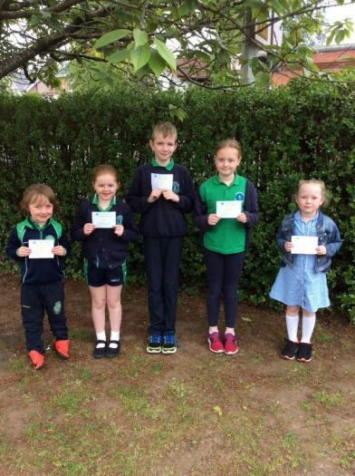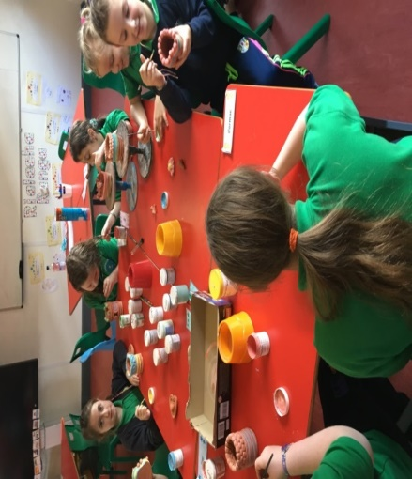

Is maith liom Gaeilge a fhoghlaim agus ticéid a bhaint as Gaeilge a labhairt.
Am Ciorcail

Tugann seisiúin Am Ciorcail deis do dhaltaí labhairt faoina gcuid braistintí agus mothúchán. Tugann siad deiseanna chun Gaeilge agus scileanna éisteachta a fhorbairt. Spreagtar dea-chaidrimh le páistí eile agus leis an fhoireann agus forbraíonn féinurraim agus muinín dá bharr.

Oideachas Drugaí

Creideann Gaelscoil an tSeanchaí go dtéann mí-úsáid drugaí salach ar shaol sláintiúil. Múintear do dhaltaí óga tábhacht roghanna sláintiúla (bia, deochanna, aclaíocht) agus foghlaimíonn siad faoi iarmhairtí nuair nach ndéantar roghanna sláintiúla. Bíonn deiseanna ag na páistí is sine an t-eolas atá acu a fhorbairt ar roghana saoil trí fhoghlaim faoi impleachtaí caite tobac agus ólacháin ar an chorp.

Caidrimh & Oideachas Gnéis
Leanaimid linn ag cur dea-chaidrimh chun cinn le daoine eile trí ghníomhaíochtaí agus trí nósanna laethúla. Leanann páistí Rang 4-7 clár struchtúrtha le cuidiú leo a thuilleadh a fhoghlaim faoi chaidrimh le daoine eile ina dteaghlach agus taobh amuigh de. I R7, tá deis ag paistí a thuilleadh a fhoghlaim faoina mothúcháin agus faoina n-athruithe coirp a tharlaíonn le linn caithreachais. Oibreoimid go dlúth le tuismitheoirí le linn an ama sin agus tá sé de cheart ag tuismitheoirí a iarraidh nach mbeidh a bpáistí páirteach sna ceachtanna sin.

Dea-Iompar
Cothaítear agus spreagtar dea-Iompar i nGaelscoil an tSeanchaí agus tá féinurraim agus aitheantas iarrachta lárnach sa chur chuige sin. Sa tionól seachtainiúil roghnaítear páistí ó gach rang agus tugtar teastas ‘Daltan Gaelgeoir agus Oibrí na Seachtaine’ dóibh. Ina theannat sin ugtar duaiseanna don tinreamh agus don phoncúlacht.

Smacht
Cuireann Gaelscoil an tSeanchaí cur chuige a thacaíonn leis an pháiste i bhfeidhm i dtaca le fadhbanna iompair a bhainistiú. Leanfaidh páistí a léiríonn an cineál sin iompair na céimeanna thíos:
- Seans eile
- Am amuigh (5 bhom/am sosa)
- Cárta Bán (rabhadh)
- Cárta Buí (labhraíonn an leas-phríomhoide leis an pháiste)
- Cárta Dearg (litir / scairt gutháin ar an teach agus cruinniú idir na tuismitheoirí agus an príomhoide)
Má fhaigheann do pháiste cárta, cuirfear abhaile é agus iarrfar ort é a shíniú agus é a chur ar ais chun na scoile. Tá failte romhat ar ndóigh teagmháil a dhéanamh leis an scoil chun imní ar bith a phlé.
Ní mór céimeanna 1-4 a chur i bhfeidhm taobh istigh de choicís sula féidir cárta dearg a thabhairt amach.
Déanfaidh foireann agus pobal Ghaelscoil an tSeanchaí a seacht ndícheall tromaíocht a aimsiú agus tabhairt fúithi go luath. Má chreideann tuismitheoir go bhfuil an páistí thíos leis mar gheall ar an tromaíocht nó má tá siad buartha faoi pháiste eile ba chóir dóibh na nósanna imeachta a leanúint ar leathanach 22 sa doiciméad seo agus teagmháil a dhéanamh leis an mhúinteoir ranga i dtús báire. Tá an Polasaí Frithbhulaíochta ar fáil ach é a iarraidh ó Oifig na scoile.
Is maith liom an scoil seo mar tá muid ábalta labhairt i nGaeilge agus níl a lán daoine eile ábalta seo a dhéanamh. Tá sé speisialta.

Creideamh

Bíonn na páistí ag foghlaim faoin dóigh ar chóir cónaí le daoine eile thart ar an domhan nó anseo i Machaire Fíolta. An dóigh le bheith tuisceanach, dea-bhhéasach, le bheith cineálta agus riachtanais daoine eile a aithint.
Cé nach scoil Chaitliceach í Gaelscoil an tSeanchaí, aithníonn muid gur Caitlicigh iad formhór na bpáistí agus a dtuismitheoirí agus mar sin de, déantar na páistí réidh do na Sacraimintí. Munar mhaith leat go mbeidh do pháiste páirteach san ullmhucháin, tá sé de cheart agat a iarraidh nach mbeidh sé / sí i láthair.

Caidrimh Phoiblí
Tá deiseanna ag daltaí i nGaelscoil an tSeanchaí le bheith pairteach i ngníomhaíochtaí éagsúla agus áiseanna a roinnt leis an phobal áitiúil. Tiomsaíonn ár ndaltaí airgead gach bliain do charthanachtaí éagsúla Trócaire agus Naomh Uinseann de Pól san áireamh. Tá dlúthnascanna againne leis an Eaglais Baptist, Colaiste na Speiríní, Glór Mhachaire Fíolta agus Gaelcholáiste Dhoire.

Comhairle na nDaltaí

Tá Comhairle Daltaí sa scoil ó Rang 4 – 7 faoi threoir Rachael Nig Uiginn. Bunaíodh Comhairle na nDaltaí sa scoil I 2015 le go mbeadh deis ag na daltaí a mbarúlacha a nochtadh ar shaincheisteanna scoile. Toghann gach rang beirt ionadaí ar Chomhairle na nDaltaí a bhuaileann le chéile ar bhonn míosúil. Is mór againn tuairimí ár gcuid páistí agus tuairiscítear ar ais iad dár mbainisteoirí.
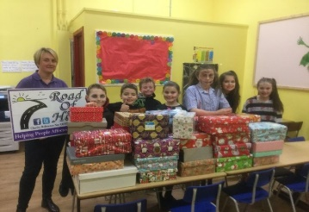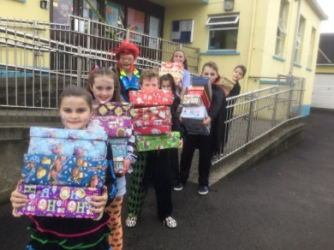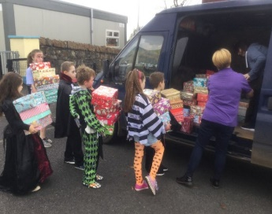
Rannpháirteachas Tuismitheoirí

Creidimid go bhfuil bunról ag tuismitheoirí le cuidiú lena gcuid páistí foghlaim. Spreagaimid tuismitheoirí le tacú leis an obair bhaile, tacú lena gcuid paistí lena gcumas Gaeilge féin a fheabhsú (ag freastal ar ranganna Gaeilge sa scoil nó ar rangana eile Gaeilge le sainghníomhaíochtaí Gaeilge eile). Cuirimid ar chumas tuismitheoirí chun tacú lena bpáistí trí cheardlanna agus trí thraenáil do thuismitheoirí a éascú. Tá PTA gníomhach againn sa scoil, Cairde agus Teaghlaigh le Chéile, a eagraíonn roinnt gníomhaíochtaí rathúla tiomsaithe airgid mar aon le tacú le himeachtaí scoile le linn na bliana. Cuirtear fáilte roimh bhaill úra i dtólamh.
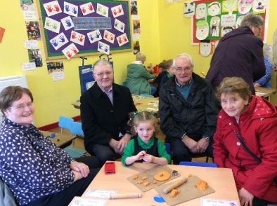
Cuairteanna Scoile
Bíonn oíche oscailte eagraithe Mí na Nollag do thuismitheoirí atá ag smaoineamh ar a bpáistí a chur chuig Naíscoil nó Gaelscoil an tSeanchaí. Bíonn cuireadh eile tugtha Mí an Mheithimh le teacht agus bualadh lena múinteoirí, Príomhoide agus foireann na scoile. Tugann na laethanta seo blas níos fearr ar shaol na scoile agus tugann siad deis duit aithne a chur ar an fhoireann.
Ag Tuairisciú do Thuismitheoirí
Bíonn cruinniú curaclaim ag tús gach scoilbhliana nuair is féidir foghlaim faoi na hábhair a dhéanfaidh do pháiste an bhliain sin. Bíonn cruinniú aonair eile leis an mhúinteoir sa chéad téarma nuair a phléitear dul chun cinn do pháiste. Scríobhann an múinteoir ranga tuairisc ag deireadh gach scoilbhliana chomh maith.
Scoileanna Roghnaithe ag Daltaí Rang 7

2016
Gaelcholáiste Dhoire | 4
Naomh Pius | 3
2017
Gaelcholáiste Dhoire | 3
Naomh Pius | 3
Coláiste na Spéiríní | 1
Colasite N.Pádraig Machaire Reatha | 1

2018
Gaelcholáiste Dhoire | 5
Naomh Pius | 5
Coláiste na Spéiríní | 1
2019
Gaelcholáiste Dhoire | 9
Naomh Pius | 1
Coláiste na Spéiríní | 3
Coláiste N.Pádraig Machaire Reatha | 2
Scoil Ghramadaí Naomh Mhuire | 1

2020
Gaelcholáiste Dhoire | 4
Naomh Pius | 4
Coláiste na Spéiríní | 2
Coláiste N. Iósaef | 1
Scoil Ghramadaí Naomh Mhuire | 1

Gearáin
Is aidhm dúinn é plé le gearáin nó le himní ar bhonn iomlán gairmiúil agus impímid oraibh na nithe a leanas a dhéanamh má bhíonn imní ort:

Céim 1
Scríobh chuig an phríomhoide

Céim 2
Mura bhfuil réiteach ar an ghearán i ndiaidh Céime 1, scríobh chuig Cathaoirleach Bord Gobharnóirí

Má tá tú go fóill buartha, thig lieat teaghmháil scríofa nó labhartha a dhéanamh leis an Northern Ireland Public Services Ombudsman

Tá ár bPolasaí Gearáin ar fáil ar shuíomh na scoile nó is féidir é a iarraidh ó Oifig na Scoile. Ba mhaith linn cur ina luí ort go bpléifear gearán nó imní atá agat chomh gairmiúil agus chomh rúnda is féidir.

Contents

- Principal’s Welcome…………………………………………………….......
- Contact Information………………………………………………………...
- School Holidays………………………………………………………………

- Admissions Arrangements – Naí-Aonad an tSeanchaí……………….
- Admissions Arrangements – Gaelscoil an tSeanchaí…………………
- Gaelscoil an tSeanchaí - Mission Statement…………………………...
- School Governors…………………………………………………………....
- Gaelscoil an tSeanchaí Staff………………………………………………
- Naí-Aonad Daily Routine…………………………………………………...
- Naí-Aonad Curriculum……………………………………………………...
- Gaelscoil Curriculum………………………………………………..………
- English………………………………………………………...………...……...
- Special Educational Needs……………………………………………..…
- ICT…………………………………………………………………………..…..
- Homework………………………………………………………………...…..
- Gaelscoil Daily Routine……………………………………………………..
- Punctuality & Attendence…………………………………………………
- School Meals………………………………………………………………….
- Healthy Eating Policy……………………………………………………….
- School Uniform……………………………………………………………….
- Jewellery………………………………………………………………………
- Bilingualism……………………………………………………………………
- Extra-Curricular Activities…………………………………………………...
- Child Protection and Safeguarding……………………………………..
- Guidelines Relating to Safety……………………..………………………
- Pastoral Care…………………………………………………………………
- Circle Time…………………………………………………………………….
- Drugs education……………………………………………………………..
- Relationships and Sexuality Education………………………….………
- Positive Behaviour…….……………………………………………………...
- Discipline……………..………………………………………………………...
- Religious Education………………………………………………………….
- Community Relations………………………………………………...……..
- Student Council………………………………………………………………
- Parental Involvement……………………………………………………….
- School Visits…………………………………………………………………...
- Reporting to Parents……………...…………………………………………
- Schools Chosen by Primary 7 pupils………………………………………
- Complaints…………………………………………………………………….

Principal’s Welcome

Dear Parent,

On behalf of all the staff in Naí-Aonad and Gaelscoil an tSeanchaí, I warmly welcome you and your child to our school. We hope your child will soon feel at home and be very happy here during these important formative years of nursery and primary education.
We are delighted that you have chosen Irish Medium education for your child and in particular, Gaelscoil an tSeanchaí.
We have produced this prospectus to help you learn more about the life and work here in our school. Parental support has always been a very important strength in our school. We welcome it as we believe that it is through working together that we can ensure the success of your child. We encourage any questions, ideas or feedback you may have regarding aspects of school life. Continual development is central to our aims and we believe that your child will have the wonderful opportunity to learn Irish in an enjoyable and enriched environment. The advantages of a bilingual education are included in this prospectus. We aim to create happy, competent and confident bilinguals.

I look forward to working with you.

Deirdre Nic Suibhne
Principal

Contact Information

Gaelscoil &Naí-Aonad an tSeanchaí

ADDRESS: 40 Meeting Street
Magherafelt
Co.Derry
BT45 6BL
PHONE: 028 79300532 (Bunscoil)
028 79634663 (Naí-Aonad)

E-MAIL: info@gaelscoilantseanchai.belfast.ni.sch.uk

CHAIRPERSON OF THE
BOARD OF GOVERNORS: Jacinta Duggan

PRINCIPAL: Deirdre Nic Suibhne

STATUS: Maintained

TYPE: Irish-medium Primary School
AGE RANGE: 3 & 4 – Naí-Aonad
4 – 11 - Gaelscoil

NUMBER OF PUPILS: 26 Nursery
113 School
% ATTENDANCE 2014 - 2015: 94.7%
% ATTENDANCE 2015- 2016: 95.2%
% ATTENDANCE 2016- 2017: 96.8%
% ATTENDANCE 2017- 2018: 96.4%

www.gaelscoilantseanchai.com

School Holidays / Laethanta Saoire 2018 – 2019 (Provisional)

School starts back on Thursday 31st August for Rang 1, 3rd September for Naíscoil and Monday 2^{4th} August for all other pupils.

September | 25
October | 26-30
November | 27
December | 23-31
January | 1-6
February | 15-19
March | 17-18
April | 2-9
May | 3-4  28-31
June | 28-30

Admissions Arrangements – Naí-Aonad an tSeanchaí
Admissions criteria to be used in the event of the school being oversubscribed in relation to
Admissions Criteria
A timetable of pre-school admissions procedures setting out the dates by which an application is to be submitted is available at www.eani.org.uk/admissions under ‘Pre-School Admissions’. During the admissions procedure when applying the criteria punctual applications will be considered before late applications are considered.

The application procedure opens on 7 January 2020 at 12noon (GMT) and an application submitted by the closing date of
30 January 2020 at 12noon (GMT) will be treated as a punctual application. An application received after 12noon (GMT) on 30 January 2020 will be treated as a late application.

As the pre-school admissions procedure is in two stages the timetable also specifies the relevant dates at Stage 2 which will determine if an application is to be considered as punctual or late.

Admissions criteria to be used in the event of the school being oversubscribed in relation to funded places. The criteria are listed in order of priority.

Statutory Criteria:
1. Children from socially disadvantaged circumstances in their final pre-school year i.e. born between 2 July 2016 and 1 July 2017 (inclusive);
2. Children not falling within sub-paragraph (1) in their final pre-school year;

and who at the time of their proposed admission will not have a pre-school education place, whether full-time or part-time, at another school or any other premises.

Note: Children from ‘socially disadvantaged circumstances’ means a child whose parent is in receipt of (i) Income Support, or (ii) Income-based Jobseeker’s Allowance, or (iii) an award of Income Support which has been converted into an Employment and Support Allowance and the level of benefit remains the same, or (iv) Universal Credit. When parents apply for places for their child on this basis they must have their Benefit Verification stamped by the Social Security/Jobs and Benefits Office to confirm that they are in receipt of a qualifying payment. This should then be sent by the parent directly to the provider of first preference.

Sub-criteria
In the event of oversubscription on the application of a statutory criterion the sub-criteria will be applied in the order set down.

1. Children whose parent(s)/legal guardian(s) have listed an Naí-aonad an tSeanchaí as their first preference.
2. Children whose parent(s)/legal guardian(s) is a member of the teaching/ancillary staff of Naí-aonad/Gaelscoil an tSeanchaí or Naíscoil na Fíobha.
3. Children whose siblings attend Gaelscoil an tSeanchaí. (Indicate name and year group)
4. Children whose main language of communication with a parent/guardian is Irish.
5. Any remaining places will be allocated in order of age-eldest first.

Non-Statutory Criteria
Should places remain after the application of the above criteria to all children in their final pre-school year, places will be allocated to children born between 2 July 2017 and 1 July 2018 in strict chronological order (date of birth – eldest first.
Admissions Criteria after 1 September 2020
If a place(s) become available after 1 September and there are more applicants than places, then selection of pupils will be made on the application of the same Criteria to those pupils seeking admission at the time the place(s) become available.

Duty to Verify
The Board of Governors reserves the right to require such supplementary evidence as it may determine to support or verify information on any applicant’s Application Form. The provision of false or incorrect information or the failure to provide verifying documents according to the required deadline may result in the withdrawal of a place.

Waiting List Policy
Should a vacancy arise after Monday 8 June 2020 all applications for admission to Nái-aonad an tSeanchaí that were initially refused, new applications, late applications and applications where new information has been provided will be treated equally and the published criteria applied. This waiting list will be in place until 30 June 2021.

ADMISSIONS CRITERIA

During the admissions procedure when applying the criteria punctual applications will be considered before late applications are considered. The application procedure opens on 7 January 2020 at 12noon (GMT) and an application submitted by the closing date of 30 January 2020 at 12noon (GMT) will be treated as a punctual application. An application received after 12noon (GMT) on 30 January 2020 will be treated as a late application.

The Board of Governors has determined that the following criteria shall be applied successively, in the order set down below, in the event of the number of children applying for places in Year 1 being greater than the admissions number.

- Children of compulsory school age with a brother or sister attending Gaelscoil an tSeanchaí including a half brother or sister.
- Children of compulsory school age who have a brother / sister (half-brother / half-sister) who is a past pupil of Irish-medium education.
- Children of compulsory school age who have attended Naí-Aonad an tSeanchaí or Naíscoil na Fíobha.
- Children of compulsory school age whose parent/guardian works either in Gaelscoil/Naí-Aonad an tSeanchaí or Naíscoil na Fíobha in a paid or voluntary capacity.
- Children of compulsory school age who have selected Gaelscoil an tSeanchaí as their first preference.
- Children of compulsory school age who use Irish as a common communicative medium with at least one parent/guardian.
- Children of compulsory school age living closest to school gate (walking/driving distance from parents’ home measured by public road only).
- Other children of compulsory school age on the basis of the order of dates of birth (eldest first).

In the event of a tie break being required children will be selected on the basis of the initial letter of their surname (as entered on their Birth Certificate) in the order set out below.

B Ní W Z N J T D L I H U M Mac G S Nic Ó A V C X de O P Q R Nig Mc E Y K F

In the event of surnames beginning with the same letter the subsequent letters of the surname will be used in alphabetical order. In the event of two identical surnames the letters of an equal number of forenames in their order of occurrence (as entered on Birth Certificate) and according to alphabetical order will be used. In the event of the forenames used having the same letters a random recorded selection will be utilised.

YEAR 1 ADMISSIONS – AFTER 1 SEPTEMBER 2020

Applications for admission will be accepted provided they are received in the school office before the beginning of the Halloween holidays. If a place(s) become available and there are more applicants than places then selection of pupils will be made on the application of the Year 1 Admissions Criteria to those pupils seeking admission at the time the place(s) become available.

DUTY TO VERIFY

The Board of Governors reserves the right to require such supplementary evidence as it may determine to support or verify information on any applicant’s application form.

WAITING LIST POLICY

The school’s policy on the consideration of any additional applications after the Open Enrolment Admissions Procedure concludes on 28 April 2020 is to apply the same criteria to the additional applications and to place them on the waiting list.

ADMISSION TO P2 – P7

It is expected that any child admitted into Years 2-7 will already command sufficient Irish to be taught in the relevant year group. This will be deemed to be the case when a parent of the child demonstrates the child has attended Irish-medium education for the duration of his/her primary education.

Pupils will be considered for enrolment provided that:

- the school would not exceed its enrolment number; and
- in the opinion of the Board of Governors their admission would not prejudice the efficient use of the school's resources.

If, at the time of the consideration of the application, there are more eligible applicants than places available then the Admissions Criteria for entry to Year 1 of pupils of compulsory school age will be applied.

Applications and Admissions to Primary 1
Year | Total Applications | Total Admissions
2017/2018 | 21 | 20
2018/2019 | 17 | 17
2019/2020 | 20 | 19

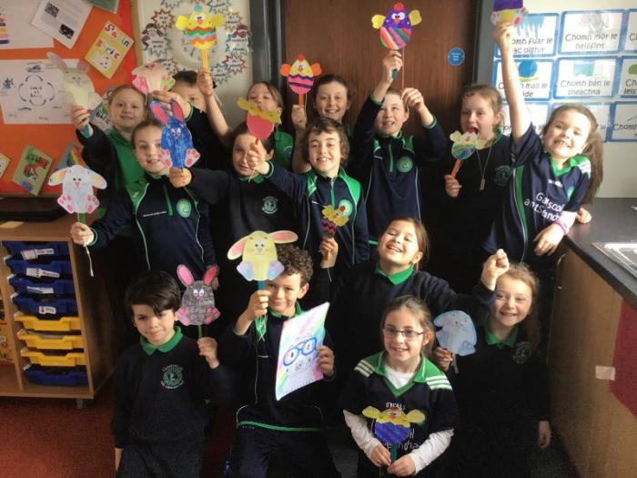

Mission Statement
Gaelscoil an tSeanchaí is committed to the development and growth of the whole person, in a rich Irish language environment which supports learning, celebrates endeavour and prepares our children for an ever changing technological world. Fundamental to the inclusive ethos of our school is the recognition of each pupil as an individual with his/her own special abilities, gifts, needs, personality and cultural background. We aim to foster a caring, supportive environment within a well ordered school community, where staff and pupils can work together in an atmosphere of mutual respect, so that each and every individual can achieve the highest level of intellectual, personal, physical and social development of which he/she is capable, within the context of the Northern Ireland Curriculum.
Aims

- To provide a safe, secure, stimulating learning environment

- To provide a relevant and balanced curriculum that fulfills the needs of all pupils, in a motivating and meaningful context, taking account of their past experiences and future learning needs

- To recognise and acknowledge that all our pupils have talents and to nurture each child’s potential

- To develop a pupil’s self-esteem and self-confidence and to encourage an appreciation of personal achievements and aspirations

- To foster, in partnership with parents and pupils, a system of pastoral care which promotes each pupils’ respect for themselves, others and the environment and which develops important values such as self-discipline, honesty, kindness and forgiveness so that they can become active and responsible members of society

- To ensure that each pupil leaves our school equipped, as far as he/she is personally capable, with the knowledge, skills, values and attitudes necessary for living in a changing social, political, cultural and technological environment

- To promote the development of a positive attitude towards a healthy lifestyle

- To celebrate and promote our Irish cultural identity while also creating an inclusive environment where diversity among individuals is embraced, celebrated and responded to and equal opportunities are available to all

- To establish a creative and secure educational partnership between the school, the home, and the wider community

- To develop a love for learning and a motivation to ask questions, to make informed decisions and to prepare pupils to take a positive role in future learning, beyond Naí-Aonad and Gaelscoil an tSeanchaí

- To support each child in their commitment to a faith community, whatever that may be. That they are able to pray and have developed a sense of a relationship with God and a sense of belonging to a faith community.

I love this school because we’re able to speak in Irish and not everybody is able to do that. It’s very special.

Vision For The Future
- To continue promoting the strong Irish language ethos of the school

- To ensure that pupils and staff feel safe, happy and successful

- To maintain high standards of pastoral care within the school

- To maintain a positive, caring environment through continued partnership between the school, home and wider community
- To ensure high standards in the delivery of the curriculum and pupil achievement
- To develop shared leadership through the role of co-ordinators and senior management within the school
- To ensure that the school meets the requirements brought about by changes to the curriculum and ICT
- To ensure the continued professional development of all staff in order to achieve high standards of pastoral care and teaching and learning
- To continue to incorporate curricular and pastoral changes and initiatives in whole school development
- To ensure that staff have an input into school development work
- To encourage pupil participation in important decisions relating to school life
- To develop the use of the outdoor environment to enhance teaching and learning
- To develop an attractive, stimulating, learning environment for pupils and staff
- To ensure continuing improvements in provision of curricular resources
- To ensure continuing improvements in security, maintenance and resourcing of the premises

School Governors / Gobharnóirí Scoile

Chairperson  Education Authority | Jacinta Duggan
Vice-Chairperson  Trustee Representative | Majella Bateson
Secretary | Deirdre Nic Suibhne  (non-voting)
Teacher Representative | Substitute
Parent Representative | Eimear O’Kane
DENI | Deirdre Ní Chinnéide
Trustee Representative | Mark Gribben
Education Authority | Déaglán Ó Doibhlín
Trustee Representative | Louise Mc Quillan
Trustee Representative | Vacancy

I love this school because it means I can help my Mammy speak Irish at home. I know everybody in the school and that’s a good thing too.

Gaelscoil an tSeanchaí Staff / Foireann na Scoile 2016-17

Principal | Deirdre Nic Suibhne
Secretary | Rosaleen Mc Williams

Foundation Stage / Bonnchéim
Naí-Aonad Teacher | Bríd Uí Choinn | •Naíscoil Designated Child Protection Officer  •

Rang 1 Teacher | Daniel Ó Donnaile
Rang 2/3 Teacher | Caitríona Nic an tSaoir | • Designated Child Protection Officer

Key Stage 1 / Eochairchéim 1
Key Stage 2 /Eocharchéim 2

Rang 3/4 Teacher | Eibhlín Nic an tSaoir
Rang 5/6 Teacher | Síle Nic Giolla Domhnaigh
Rang 7 Teacher | Eiméid ó Raifeartaigh

Classroom Assistants / Cúntóirí Ranga
Teresa
Claire Ní Chnáimhsí
Lorraine Cox
Joanne Smith
Clár Ní Dhornáin

Auxiliary Staff / Foireann Chúnta
Cleaner | Bernie Davey  Mary Henry
Lunchtime Supervisors | Bernie Davey  Lorraine Cox  Claire Ní Chnáimhsí  Danielle Murphy  Naomi Doyle

I like this school because we go on a lot of trips and we do a lot of sport.

The School Day – Naí-Aonad

Naí-Aonad class times are from 9.00am – 12.30pm. There is a staggered arrival time and children may arrive anytime between 9.00-9.20. This gives parents the chance to talk to the staff if need be.

There is a healthy snack available to the children until 10.20am at a cost of £20 per month.

Pre-School Curriculum / Curaclam Réamhscoile

The pupils in the Naíscoil cover the Northern Ireland Curriculum (Foundation Stage)

• Language Development
Talking and listening, reading, writing, rhyming, syllables, phonological awareness

• Personal, social and emotional development
Circle time, exploring feelings, taking care of the environment, independence and social skills

• Early mathematical experiences
Colours, shapes, numbers, matching, Sorting, patterns, Jig-saws

• Physical development and movement
Walking, running, crawling, jumping, hopping, climbing, ball skills, throwing

• Gross and fine motor skill development
Cutting, threading, writing, sticking, using cutlery

• The Arts
Junk art, singing / percussion instruments, imaginative play, drama / role play

• The World Around Us
Taking care of the environment, planting and growing, safety

Primary Curriculum / Curaclam na Bunscoile

The primary curriculum is broken into three keystages:

Foundation Stage (Naíscoil, Rang 1 &2)
Key Stage 1 (Rang 3 & 4)
Key Stage 2 (Rang 5, 6 & 7)

The pupils of the school are taught the subjects of the Northern Ireland Curriculum, the exact same as their peers in our neighbouring English medium schools. The subjects encompass a range of learning areas:

• Language and Literacy
- reading, writing, talking & listening.
• Mathmatics and Numeracy
- number, shape & space, handling data, sorting, patterns, measures, processes.
• The World Around Us
- geography, history, science and technology
•Personal Development
- personal health and safety, mutual understanding.
• The Arts
- art, music, drama
• Physical Education
• Religion

We acknowledge that pupils learn in different ways, therefore when planning we take into the account the different forms of intelligence ensuring where possible there is a Visual, Auditory and Kinaesthetic element to each of our lessons.

English / Béarla
Children are taught through the medium of Irish alone in the early years to allow the acquisition of the language in a way that is natural and structured. English as a formal curriculum subject is introduced in Rang 3 and these lessons are delivered through the medium of English. It is our target that the children will acquire the same standard of reading and writing at the end of Rang 7 as their counterparts in English medium schools.

Special Educational Needs / Riachtanais Speisialta Oideachais

In Gaelscoil an tSeanchaí, we follow the guidelines from the Department of Education with regards to the mangement of and provision for special educational needs. Teachers identify and implement appropriate strategies to support all children in their classes and liaise with the SENCo (Special Educational Needs Co-ordinator) to devise education plans for all pupils that have been registered on the school’s special educational needs register. Gaelscoil an tSeanchaí follows a five stage approach to the management of and provision for special educational needs, as guided by the Code of Practice (DENI, 1998). Each case is reviewed and monitored on an individual basis and a partnership model is used to ensure that teachers, parents, SENCOs, outside agencies and of course the children themselves are as informed and as pro-active as possible. A copy of the Special Educational Needs policy is available on request.

ICT / TFC

Gaelscoil an tSeanchaí aims to acquaint all children with all aspects of ICT and see its relevance and importance in everyday life. Pupils are made aware of the ways computerised information can be made to work for them. They will also develop an awareness of how ICT can sometimes be misused and of ways to protect themselves and information. Our school ICT and Internet Access Policy is available on request.

Homework / Obair Bhaile
Homework is a very important part of the work of our school and is a point of regular contact for many parents with the school. Each child will be given homework, suitable to his/her ability in order to:
a) reinforce work done in class
b) help him/her develop a habit for personal study
c) keep parents up to date with their child’s work, and
d) give parents an opportunity to become involved in their child’s work.

Parents should read with their child and sign any written homework each night.
The School Day / Gnáthlá Bunscoile

__________________________________________________________________________________

Class Times

Naí-Aonad 9.00am -12.30pm
Rang 1 & 2 9.00am – 2.00pm
Rang 3 9.00am – 2.00pm (until Halloween)
9.00am – 3.00pm (after Halloween)
Rang 4 – 7 9.00am – 3.00pm

Primary pupils have a supervised break during the morning session. They are allowed only a healthy snack and your co-operation would be very much appreciated, fruit or vegetables are recommended.
__________________________________________________________________________________

Lunch Time

Rang 1 -4 12.00pm – 12.45pm
Rang 5 – 7 12.45pm – 1.30pm

School dinners are provided in the school. They are cooked in Magherafelt Primary School and cost £2.60. Meals are payable on a Monday morning and all monies should be given in an envelope marked clearly with your child’s name on it and the days your child requires school meals. Packed lunches are eaten in the classroom and pupils are supervised by supervisory assistants. Lunchtime assistants also supervise the dinner and lunch pupils while they are outside playing.
_________________________________________________________________________________

Club 2 – 3

Unfortunatelly because of current Covid-19 guidance and arrangements in our school we are not offering this service for the moment.
Punctuality and Attendance / Poncúlacht & Tinreamh
Every lesson in Gaelscoil an tSeanchaí has an educational value, therefore attendance and punctuality support the school’s foremost aim of pupil learning. Prolonged absences, irregular attendance and lack of punctuality can all serve to undermine educational acheievement and result in long term disadvantage to the children.
Pupils arriving late for the start of the morning will report to the school office. Pupils will be registered as late after 9.00am. The secretary will register them in the late book and, if necessary, record if a meal is required. If a pupil is recorded in the late register on more than four occasions in any calendar month, a letter will be issued to parents informing them of this. If a letter is issued on two or more occasions in any one academic term the Education Welfare Officer will be informed.

School Meals / Beiltí Scoile

If you think your child is entitled to free school meals please obtain a form from www.eani.org.uk. It is important to complete the form and return it to the address on the back as soon as possible.

Healthy Eating Policy/Polasaí ar Bhia Shláintiúil

We emphasize the importance of healthy eating and we encourage children to avoid eating foods high in salt and sugar. The school requests fruit or vegetables only for morning break. Parents are requested not to give children fizzy drinks, chocolate, sweets and crisps for lunch. Children are allowed a small treat in their lunchbox each Friday – Aoine Aoibhinn.

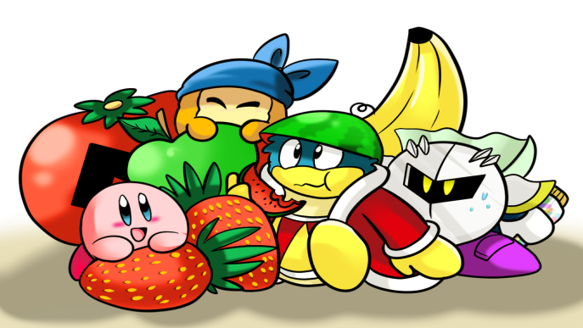
School Uniform / Éide Scoile
We expect all pupils to wear full school uniform every day. Both Naí-Aonad and Gaelscoil uniform may be purchased at Select in Magherafelt.
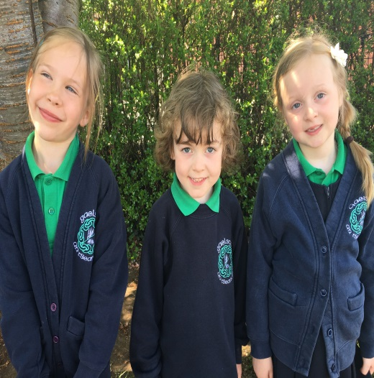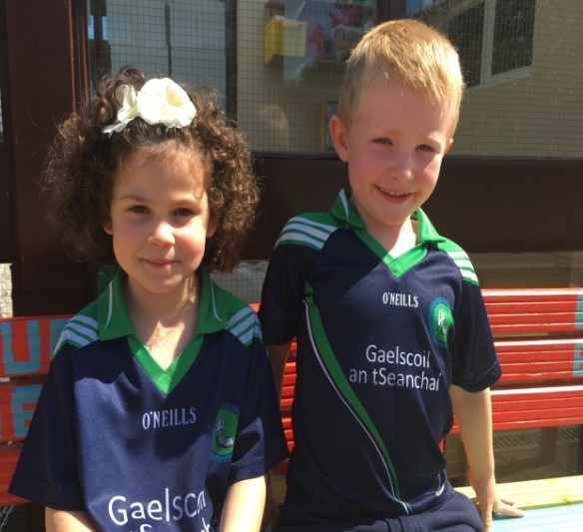

 | Cailíní / Girls | Gasúir / Boys
Naíscoil | School Jumper  Green T-shirt  Navy tracksuit bottoms  Shoes with Velcro fastenings
Rang 1 – 7 | Navyskirt / trousers  School sweatshirt  Green polo t-shirt  Black shoes  Navy socks | Navy trousers  School sweatshirt  Green polo t-shirt  Black shoes  Navy socks
PE Uniform (All pupils) | School jersey  Soft black indoor shoes

Jewellery / Seodra
For health and safety reasons, parents should discourage children from wearing jewellery, including neck chains, bracelets and earrings. However, children with pierced ears may wear small stud earrings.
I like being able to talk to my friends in Irish. I like the art we do in school too.

Bilingualism / Dátheangachas

The Irish Medium model of education involves the immersion of the child within an Irish environment so that the language is acquired naturally and without effort on the child’s part. Research shows that there are significant lifelong advantages for children who are being educated in Irish-medium Schools:
Academic Achievement
Immersion students achieve as well as or better than non-immersion peers on standardized measures of verbal and mathematics skills administered in English. A research briefing published by the Department of Education in Northern Ireland indicated that former pupils of Irish-medium schools attained a higher academic standard than might be expected among the general population of the same age group.

Cognitive Ability
Bilingual people have an improved ‘Executative Function’, a command system that directs the attention processes that we use for planning, solving problems and performing various other mentally demanding tasks.

Improved reading skills in Irish & English
A study by researchers at York University in Toronto suggests that children who are bilingual learn to read more rapidly than their monolingual peers. Bilingual children are also bilerate – they have the ability to access different literatures and read and write in both languages.

Health
A multilingual brain is quicker, nimbler and more resistant to Alzheimers and other forms of dementia.

Character Benefits
Bilingual children have a heightened sense of self esteem and confidence. They feel pride in their ability to switch languages and have a strong sense of identity. They have a greater appreciation of different cultures and have an increased sensitivity to others. They have a better ability to think creatively.

Learning additional languages
Bilingual children have a high compentency in two languages and have advantages in learning other new languages. A study carried out in the Basque country found that bilingual students display greater facility in learning a third language.

Extra- curricular Activites / Gníomhachtaí Breischuraclaim

Here at Gaelscoil an tSeanchaí we are pleased to offer a range of after-school activities for pupils and evening classes for parents. We aim to provide a relaxed, positive environment where pupils, teachers and parents can work together to develop the children’s self-esteem, confidence and physical health and well-being.

Some activites we offer are

• Drama
• Gaelic football
• Hurling / camogie
• Reading Club
• Maths club
• Tin whistle

• Computer club
• Cookery
• Art
• Spanish
• Pottery
• Choir

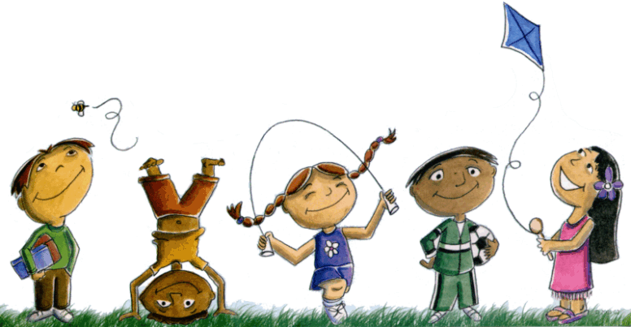

Child Protection & Safeguarding / Cumhdach & Cosaint Leanaí

Designated Teachers for Child Protection:

Caitríona Nic an tSaoir Eiméid Ó Raifeartaigh (Designated Teacher) (Assistant Designated Teacher)

Bríd Uí Choinn
(Designated teacher in the Naíscoil)

If you have concerns about a child / children, follow the steps below

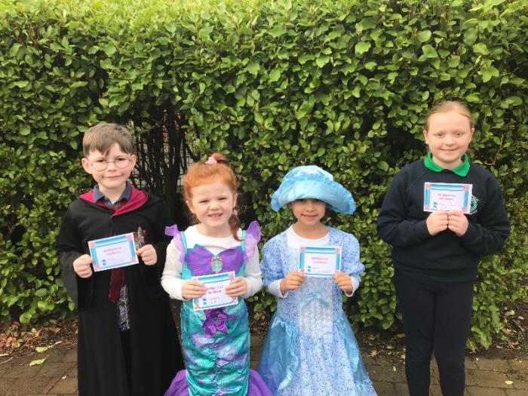
Guidelines Relating to Safety / Treoirlíntí Sábháilteachta

Parent / carers are asked to heed the following advice to ensure the health and safety of all:
● Any child who needs to leave school early must be given permission and be collected by an adult from the school office
● Arrangements for after school activities should be made with the children so that daily phone calls to the school office can be avoided.
● Contact must be made with the school by note or phone call should a child be absent for any reason.

Pastoral Care / Cúram Tréadach
Pastoral care is of paramount importance in our school. The children are safe and happy in a caring and friendly environment. Gaelscoil an tSeanchaí is an all-inclusive school where respect, kindness and care are shown to all. Staff promote confidence and self-esteem in every aspect of school life. We endeavour to meet the needs of each individual child in our care and will allow the children to grow and develop at their own pace.
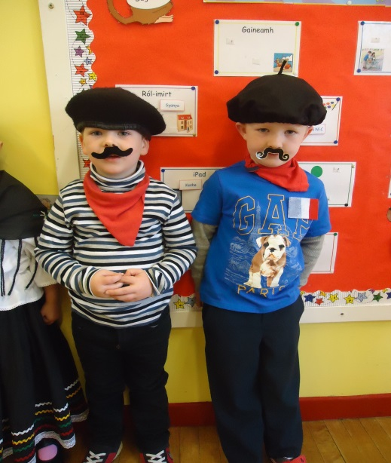

Tá mé slán sábháilte ar scoil.
Circle Time / Am Ciorcail

Circle time sessions give pupils a chance to talk about their feelings and emotions. They give opportunities for developing the children’s Irish language and listening skills. Good relationships with other children and staff are encouraged and their self-esteem and confidence develops as a result.

Drugs Education / Oideachas Drugaí

Gaelscoil an tSeanchaí believes that misuse of drugs is contrary to a healthy life. Younger pupils are taught about the importance of making healthy choices (food, drinks, exercise) and they learn about the consequences of not making healthy choices. Older children have the opportunity to further develop their knowledge of lifestyle choices by learning about the effects of smoking and drinking on the body.

Relationships and Sex Education / Caidrimh & Oideachas Gnéis
We continually promote good relationships with others within the school through day to day activities and routines. Children in R4 – 7 also follow a structured programme to help them learn more about relationships with others both within their family and outside it. In R7, children have the opportunity to learn more about their emotions and changes in their bodies which happen during puberty. We will work closely with parents during this time and parents have the right to request that their child does not participate in these lessons.

Positive Behaviour / Dea-Iompar
Positive behaviour is nutured and encouraged in Gaelscoil an tSeanchaí and promotion of self-esteem and recognition of effort is central to this approach. In weekly assembly Rang 1-7 children are chosen from each class and presented with a certificate for ‘Pupil of the Week’,’ Irish speaker of the week’ and ‘Worker of the week’. There is also an award from the principal and every week some children are taken to have hot chocolate in the staff room. Excellent attendance and punctuality are also rewarded.

Discipline / Smacht
Gaelscoil an tSeanchaí implements a child-friendly approach to managing problematic behaviour. Children exhibiting such behaviour will follow these steps:
- Be given one more chance
- Time out (5 min/break time)
- White Card (warning)
- Yellow Card (Principal made aware)
- Red Card (phone call home and meeting between parents and principal)
If your child receives a card, it will be sent home and you will be asked to sign the card and return it to school. You are of course welcome to contact the school to discuss any concern.
Stages 1-4 must be implemented within a fortnight for a red card to be given.
Gaelscoil an tSeanchaí staff and community will take every step to identify and tackle bullying at an early stage. If a parent believes that their child is the victim of bullying, or they are concerned about another child, they should follow the procedures laid out on page 22 of this document, with the class teacher being the first port of call. Our Anti-Bullying Policy is available on request from the school office.

Tá na múinteoirí agus na páistí iontach deas, cairdiúil agus cuidiúil.

- Religious Education / Teagasc Críostaí

During Religious Education, the children learn how they should live with others around the world or here in Magherafelt. They learn how to be understanding, well-mannered, kind and to recognise the needs of others.
Although Gaelscoil an tSeanchaí is not a Catholic school per se, we recognise that the majority of our children and parents come from a Catholic background. Therefore, we offer to prepare the children for the three Sacraments, Confession, Communion and Confirmation should you wish. Children are prepared for the Sacraments through the language of instruction of the school.
If you do not wish your child to participate in these preparations, you have the right to request that your child be withdrawn from such classes. Children from all faiths or none are welcome in Gaelscoil an tSeanchaí.

Community Relations / Caidrimh Phoiblí
Pupils in Gaelsoil an tSeanchaí have opportunities to participate in various activities and share resources within the local community. Our pupils fundraise for numerous charities including Trócaire, St. Vincent de Paul and The Shoebox Appeal. We have close links to Maghaerafelt Baptist Church, Gaelscholaiste Dhoire, Glór Machaire Fíolta, Sperrin College and Rossa GAA. We are part of the Shared Education with the three other prinmary schools in Magherafelt.
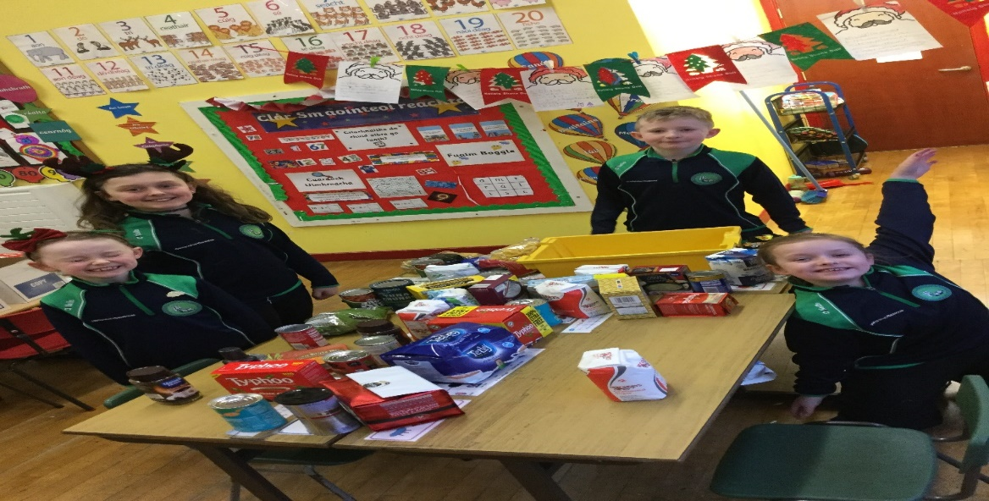
Student Council / Comhairle na nDaltaí
There is a Student Council within the school, Primary 4 – 7, guided by Caitríona Nic an tSaoir. The student council was formed in the school in September 2015 with a view to giving the children an opportunity to voice their opinions concerning school issues. Each class elects two representatives to the school council which meets on a monthly basis. Our children’s views are highly valued and are reported back to management level.

Parental Involvement / Rannpháirteachas Tuismitheoirí

We believe that parents have a fundamental role to play in helping their children learn. We encourage parents to support with homework, and to support their own children by improving their own competency in Irish (attending Irish classes in the school or other local Irish language classes in association with specialist outside agencies). We enable parents to support their children by facilitating workshops and training for parents. We also have an active PTA, Cairde agus Teaghlaigh le Chéile, within the school which have organised a number of successful fund raising activities as well as assisting at school events throughout the year. New members are always welcome.
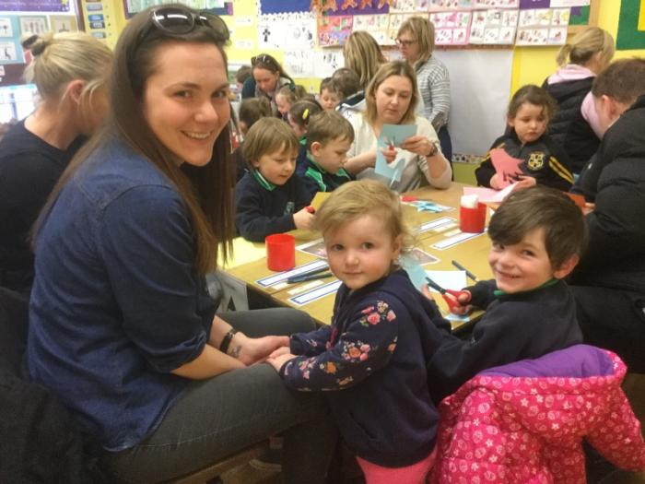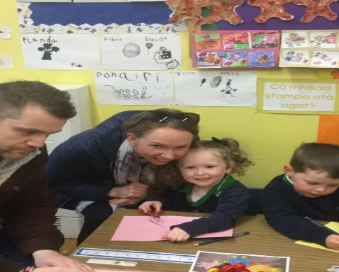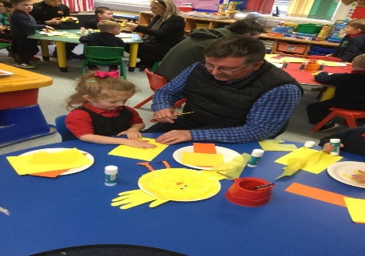

School Visits / Cuairteanna Scoile

Prospective parents to Naí-Aonad an tSeanchaí and Gaelscoil an tSeanchaí are invited to an open night in December. Another invitation to visit the school is extended in June and parents can meet their child’s teacher, the Principal and other staff. These occasions provide an excellent opportunity to become familiar with the school and to learn about school life.

Reporting to parents / Tuairisciú
A curriculum meeting is held at the beginning of each school year in which the subjects your child will study is explained. An individual meeting with your child’s teacher is organised at the end of November in which your child’s individual progress will be discussed. The class teacher writes a report to parents at the end of each school year also.

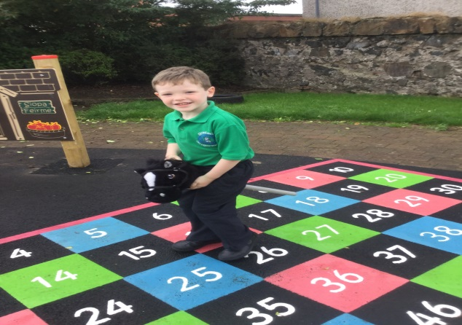

Schools chosen by Primary 7 pupils

2016
Gaelcholáiste Dhoire | 4
St. Pius | 3

2017
Gaelcholáiste Dhoire | 3
St. Pius | 3
Sperrin integrated College | 1
St. Patrick’s College, Maghera | 1

2020
Gaelcholáiste Dhoire | 3
St.Pius | 4
Sperrin College | 3
St.Josephs Donaghmore | 1
St. Mary’s Grammar | 1

2018
Gaelcholáiste Dhoire | 5
Naomh Pius | 5
Coláiste na Spéiríní | 1

2019
Gaelcholáiste Dhoire | 9
St.Pius | 1
Sperrin College | 3
St. Patrick’s College Maghera | 2
St. Mary’s Grammar | 1

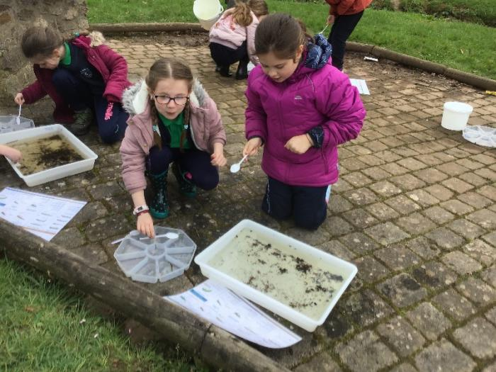
Complaints / Gearáin

We aim to deal with complaints or concerns in a totally professional manner and would urge you to do the following if you have a concern:

Step 1
Write to the principal

Step 2
If complaint is unresolved write to the Chairperson of the Board of Governors

If complaint remains unresolved you may contact the Northern Ireland Public Services Ombudsman

Our Complaints Policy is available on request from the school office. We assure you that any complaints or concerns will be dealt with professionally and as confidentially as possible.

Covid-19

Please see below additional information about the arrangements for your child’s return to school. We are hopeful that all our children will feel happy and safe at school despite all these new necessary adjustments.

- Members of the school community who display symptoms of Covid-19 MUST NOT ATTEND or VISIT OUR SCHOOL and should immediately phone their doctor and follow guidance on self-isolation

Symptoms of Covid 19
- High temperature
- Cough
- Shortness of breath or breathing difficulties
- Loss of smell, of taste or distortion of taste

- Travel from abroad: if any pupil has travelled to a country not approved for travel they should not attend school until 14 days after their return, as passengers from any location not on this list are asked by the government to restrict their movements for 14 days.

- Any pupil presenting with symptoms of Covid 19 will be immediately isolated and a parent called to collect the pupil and their siblings. The staff room has been changed into an isolation room and children who are showing symptoms will be sent here whilst awaiting collection, this should be no longer than 15mins after receiving notification.

- Visits to the school by all persons other than staff and pupils will be by appointment only. Appointments must be arranged in advance through the school office, by phone on 028 79300532 or by email. The only entry to the school for adults is through the door beside Rosaleen’s office where you must ring the bell for access. The door will not be opened to anyone who does not attend with a mask.

- No parents are allowed onto school grounds in the morning with the exception of R1-3 parents. From 7 September R2 must make their way to their classrooms independently. From 28 September R3 must make their way to their classrooms independently.

- Entry and Exit of Classrooms:
Arrival Times:
8.45 a.m. – 8:55 a.m. Rang 4 _Rang 7 pupils dropped at school
8.50 a.m. – 9.00 a.m. Rang 1-Rang 3 pupils be dropped at the school.
If you have pupils in both groups, please drop at the earlier time

- Dispersal times:
Rang 1-3 will leave their classes from 1:50pm and Rang 4-7 will begin to leave their classes at 2:50pm. Parents are asked to collect children from the school park in the area designated according to family surname and are clearly marked at a distance of 2m apart. Please stick rigidly to this arrangement and ensure you are in designated areas before children leave their classrooms.
Group A: A-L
Group B:Mc
Group C:M-O
Group D: P-Z
If a pupil walks, cycles or sees his/her parents they will proceed straight out of the school grounds. If no parent is there to collect, pupils will wait in their family group until their parents arrive. (This will be taught to the pupils on the first day back)
Please do not delay at this busy time for traffic in the evening, collect your child and depart promptly

- Parents/visitors who enter the school grounds by appointment must wear a face covering

- All visitors to the school must fill in a Contact Tracing Log

- No pupil is allowed in buildings beyond their classroom unaccompanied by a teacher or CA/SNA.

- Parents must make sure that children bring their lunches to school to avoid adults having to come to the school during the day. Please remind your children not to share their food or drinks with other children.

- Please make sure your child is self-sufficient.ie. they can open/peel any lunch/drink you pack for them. Please pay particular attention to any drinks that require a straw. No lunchboxes are allowed and all packaging and bottles must be disposable.

- Pupils should have a separate pencil case for use at home that won’t come into school.

- Please make sure they have enough drinks to last them throughout the day as we will not be in a position to refill drinks bottles.

- Classes are now called Bubbles and these are subdivided into pods

- Classes (Bubbles) may not mix with each other in the yard, but pupils from different pods within the class may play together in the yard, in as far as is possible.

- No footballs/basketballs/hurleys etc are allowed in school and no ball games will be allowed before, during or after school.

- Pupils must partake in class routines of sanitising at the sanitising points in school.

PLEASE FEEL FREE TO CONTACT THE SCHOOL IF YOU REQUIRE ANY FURTHER SUPPORT OR INFORMATION.

